**MSc-IT Sem (III)**

**Information Security management**

**Practical manual**

**2017-2018**

**INDEX**

|  |  |  |
| --- | --- | --- |
| Sr.no. | Name of Practical | Sign |
| 1 | Working with Sniffers for monitoring network communication. |  |
| 2 | Using open SSL for web server - browser communication. |  |
| 3 | Using GNU PGP. |  |
| 4 | Performance evaluation of various cryptographic algorithm. |  |
| 5 | Using IP TABLES on Linux and setting the filtering rules. |  |
| 6 | Configuring S/MIME for e-mail communication. |  |
| 7 | Understanding buffer overflow & format string attacks. |  |
| 8 | Using nmap. |  |
| 9 | Socket programming. |  |
| 10 | Exposure to client server concept of TCP/IP, Blowfish. |  |

**Practical 1**

**Aim:** Working with Sniffers for monitoring network communication (Ethereal)

**Requirement:** Wireshark.

**Solution:**

Install Wireshark

Start Wireshark. Under the “Capture” header, select the “Interface List” option; or

click on the “In*terfaces” button on the toolbar:*

*This will bring* up a list of network interfaces that Wireshark is able to capture

packets from:

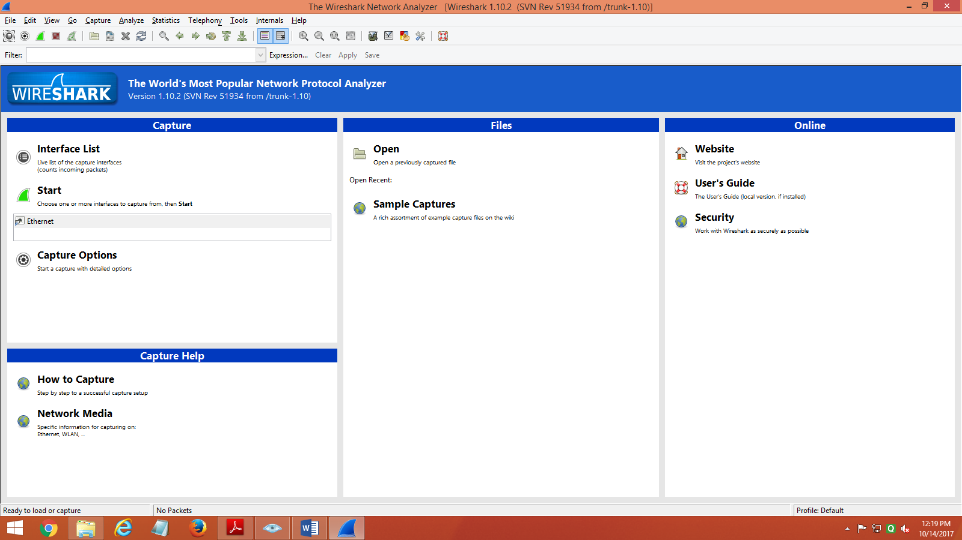

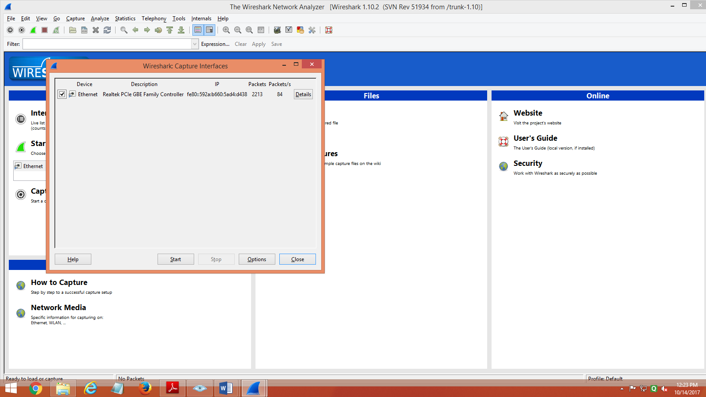

**List of available capture interfaces**

Select the network adapter (wired or wireless) that you are currently using to connect the Internet, and hit the “Start” button. This will take you to the main window:

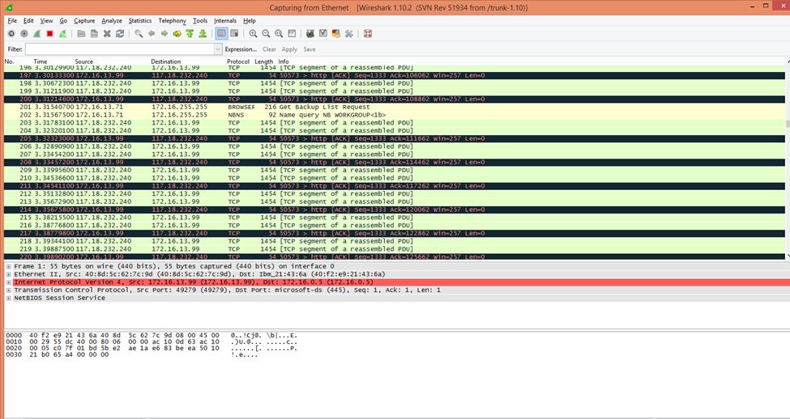

Wireshark is now capturing live network activity on your network interface. Notice that the list of packets is color-coded to highlight different types of network traffic.

Open your web browser and navigate to a few random web pages –observe that the network packets corresponding to your web browsing activity are captured and show up in Wireshark as well.

By default, the list of captured packets will keep scrolling automatically during a live capture. You can toggle this on/off using the AutoScroll toggle button in the toolbar:

After letting the capture run for a couple of minutes, press the stop capturebutton: .Do not close this capture session.

**Filtering the Packet List**

Capturing network traffic for a couple minutes could include traffic on many different protocols such as ARP, TCP, UDP, DNS, HTTP, etc.

We may not be interested in all of these, depending on what we are trying to achieve.

Fortunately, Wireshark allows us to filter the list based on different criteria using the

“Filter” toolbar:



**Filter toolbar**

In the filter toolbar, type “http” and then click on “Apply”. The window will now

list only captured packets related to HTTP traffic:



Examining HTTP Traffic the HTTP traffic that occurs during web browsing.

Stop and close any capture that you may have open, and start a new capture.

Set the filter to show only HTTP traffic.

Start with the HTTP request sent from your web browser.

In your web browser, navigate to some webpage

In the top frame of the Wireshark main window, look for the packet that corresponds to your request. This contains the URL in the “Info” section. Select this packet.

In the middle frame of the Wireshark window, expand the “Hypertext Transfer Protocol” section. Notice the details given for the:

1. GET request
2. Host
3. User-Agent
4. Accepts
5. cookie
6. etc



Details of outgoing HTTP request corresponding to proxy.html

Take a look at the HTTP response to the above request.

In the top frame of the Wireshark main window, find and select the “HTTP/1.1 200 OK” packet immediately below the request for proxy.html. This is the response containing the requested web page.

Again, expand the “Hypertext Transfer Protocol” section. Notice the details given for

1. Cache-Control

2. Content-Type

3. Server

etc

If we expand the “HTTP chunked response” section, we can find the actual data transmitted in the response.

In this case, note the web page HTML visible in the bottom frame of the window



Data section of the HTTP response, containing the web page HTML

The requested web page contained a background image, which the web browser also had to fetch.

Notice that below the two packets we have already examined, there is another pair of request and response packets corresponding to the page background image, USCwebMarble.jpg.

Examine the details of these two packets as well.

Filtering with Expressions

While we can easy to examine the traffic that occurs from browsing in a controlled environment as we have done above, things may be different in practice where there may be a large amount of traffic to sift through – simply isolating HTTP traffic may not be enough.

To locate specific packets related to individual requests or responses from a within larger capture containing more traffic, we can perform even more specific filtering using a variety of expressions relating to various header fields and their contents.

Start a new capture, and do some arbitrary web browsing, such as visiting some Wikipedia articles, reading some news, etc. Then, with the capture still active, also visit all of the web pages we used in the last

section:

Now, assuming we don’t have any prior knowledge about the order in which we visited various web pages, let’s filter the traffic using various expressions. in the filter toolbar, click on the “Expression…” button.

A dialog box will appear, showing a large list of possible packet header fields that can be

used to filter the captured network traffic.

We are of course interested in particular to the options related to HTTP traffic:

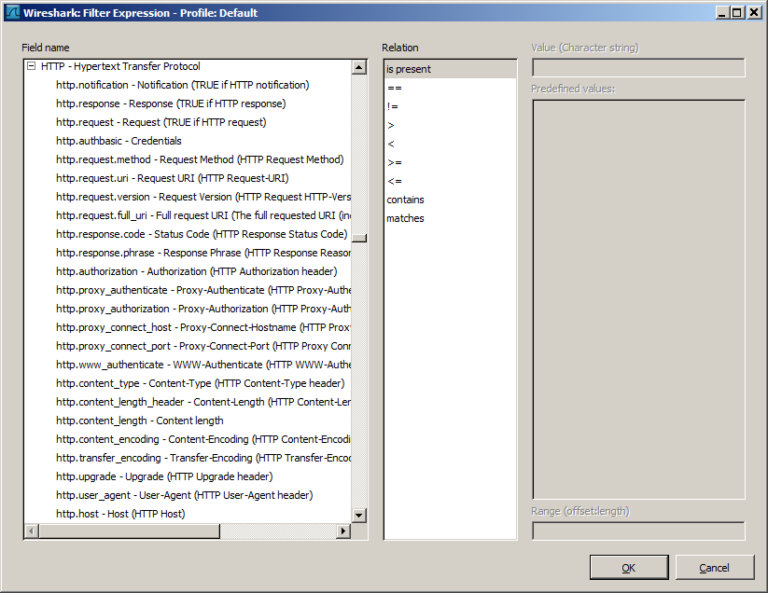

Filter expression dialog: various expressions for filtering HTTP traffic

Let’s take a look at what some of these options do.

Among the first few field options are http.request and http.response. http.request allows us to filter the traffic so that only request packets are shown; conversely, using http.response displays only response packets.

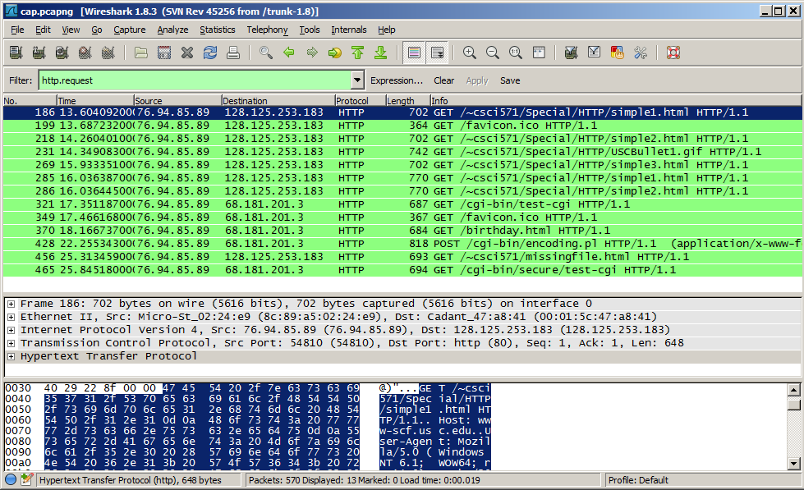

Other fields are more specific. For instance, recall the form that we submitted earlier we can find the request corresponding to that by taking advantage of the fact that the form was submitted using the POST method:



After building the filter expression and pressing “Apply” on the filter toolbar, we obtain the HTTP request packet that we were looking for:

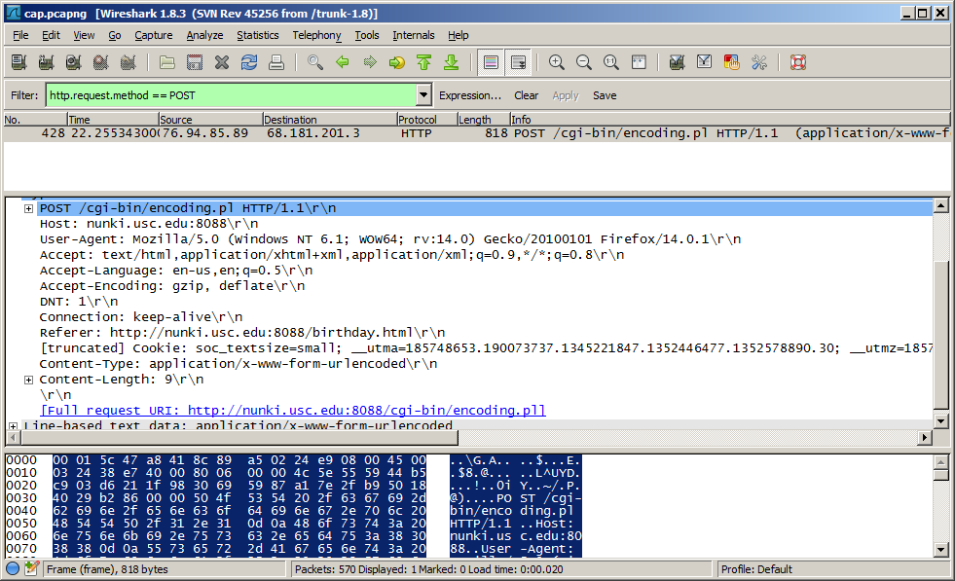

HTTP request packet corresponding to form submission using POST method

We can also look parts of URLs or whole URLs using http.host, http.request.uri and http.request.fulluri:

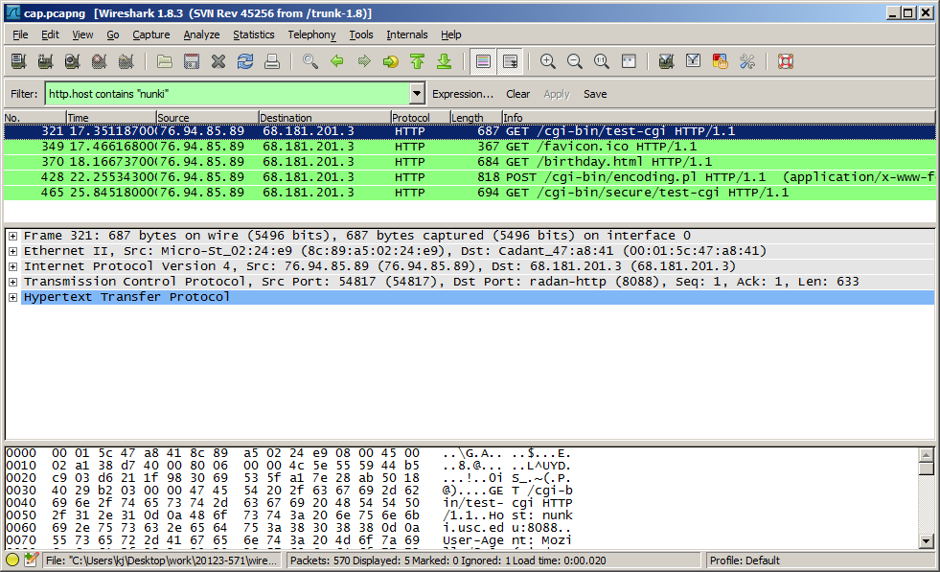

Filtering for requests to the host nunki.usc.edu

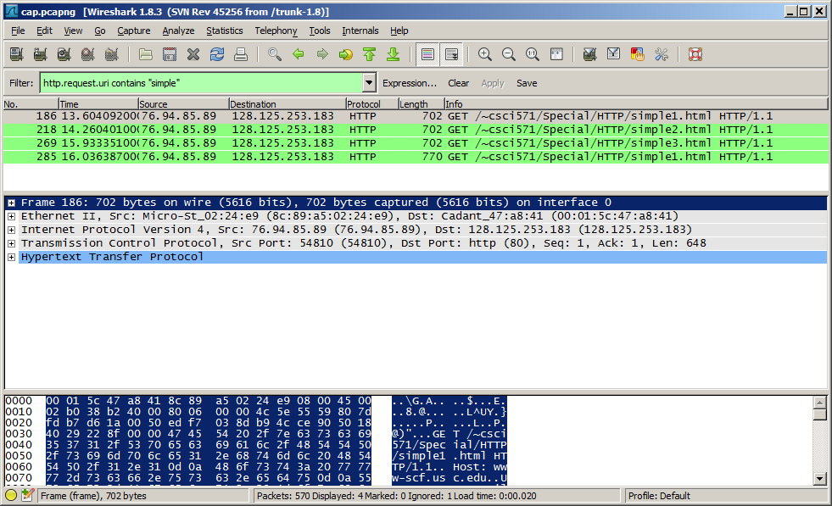

Filtering for URLs containing the substring “simple”

As well as the http.referer, such as in this case of a GIF image being loaded on simple2.html:

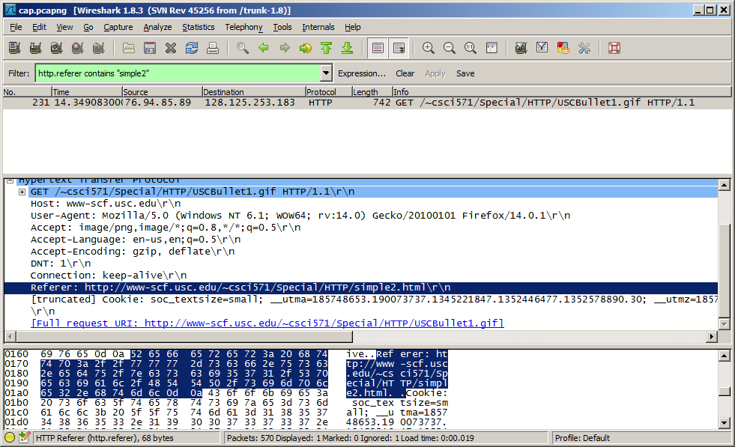

Filtering request generated by the referring page simple2.html

You can even combine multiple expressions using logical operators to form more complex filter patterns:

and : &&

or : ||

xor : ^^

not : !

In the following example, we build a filter to look for a HTTP response that served up a GIF image from a web server running Apache:

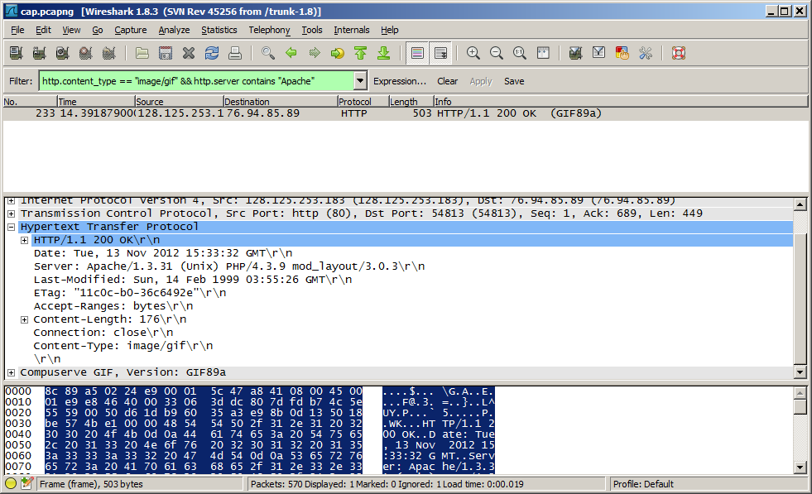

**Using logical operators**

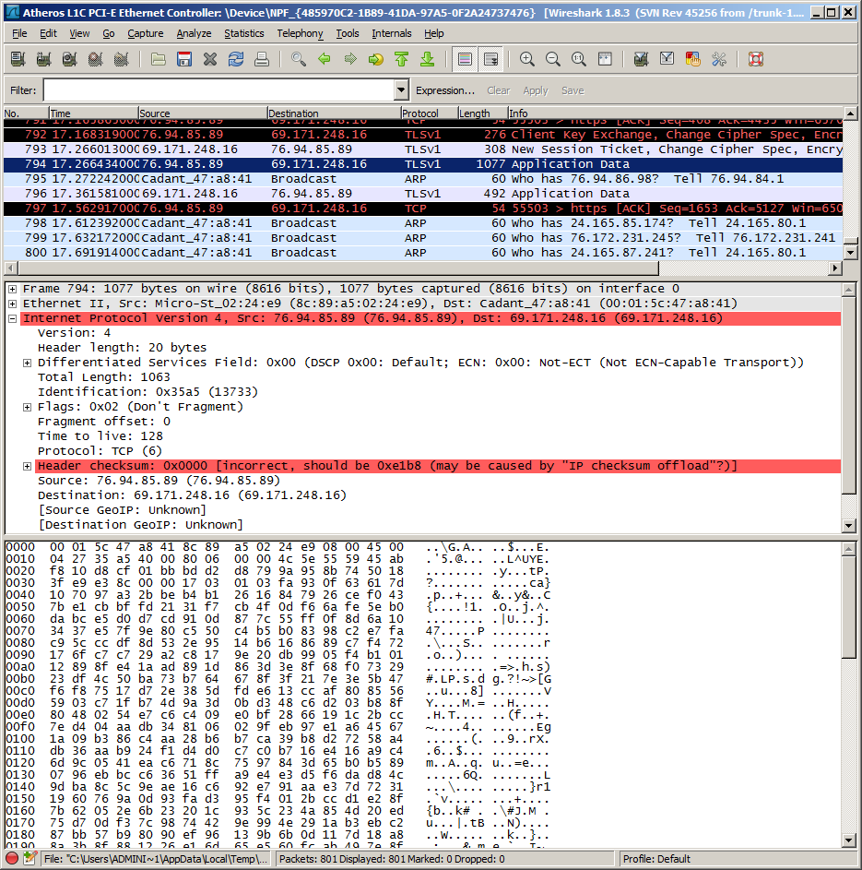

A packet with “incorrect” IP header checksum caused by checksum offloading

To make this error go away, you can disable IP checksum validation as follows:

Under the “Edit” menu, click “Preferences”

Under “Protocols” look for “IPv4”.

Uncheck the box for “Validate the IPv4 checksum if possible”

Apply the settings

The same can be done for other protocols (TCP, UDP, etc) if you find that they are affected by this same issue.

Sign:________

**Practical 2**

**Aim:** Using open SSL for web server - browser communication

**Requirement:** Red hat Linux.

Packages: openssl, mod_ssl, httpd.

**Solution :**

**To create a key and certificate:**

Open terminal and check whether SSL is installed

Command: rpm -q mod_ssl openssl

If it is not installed : rpm –ivh /media/RHEL_6.1\ i386\ Disc\ 1_/Packages/mod_ssl-2.2.15-9.el6.i686.rpm.

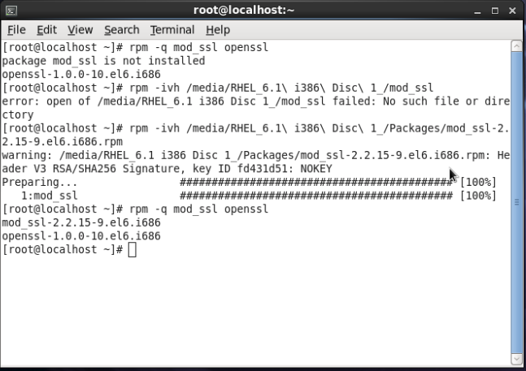

**To create a certificate make directory using command**

Command : mkdir cert

cd cert

To create a certificate

Command: openssl req –x509 –nodes –new –days 365 –newkey rsa:2048 -keyout shiva.key –out shiva.crt

(Enter all the details for the certificate)

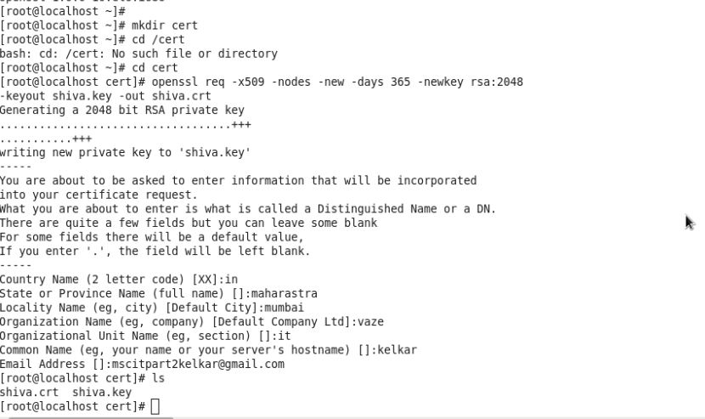

**To check the certificate**

Command: ls

To view the certificate check whether httpd service is installed or not

Command: rpm –q httpd

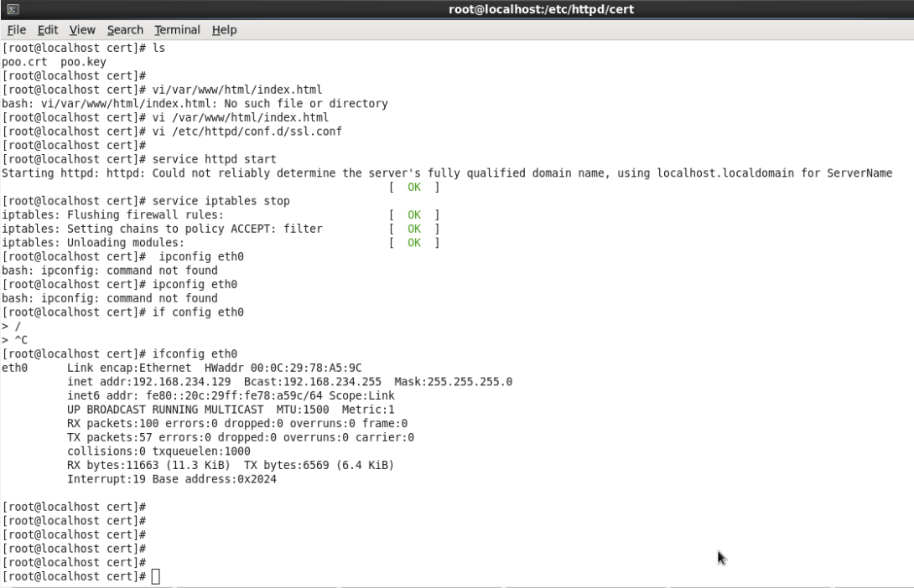

Command: vi /var/www/html/index.html (To create index.html)

To configure ssl.conf file for certificate attachment

Command: vi /etc/httpd/conf.d/ssl.conf

:105

(In ssl conf modify the certificate and key path)

Save and close using :wq

To find the ip address : ifconfig eth0

**Go to Mozilla firefox.**

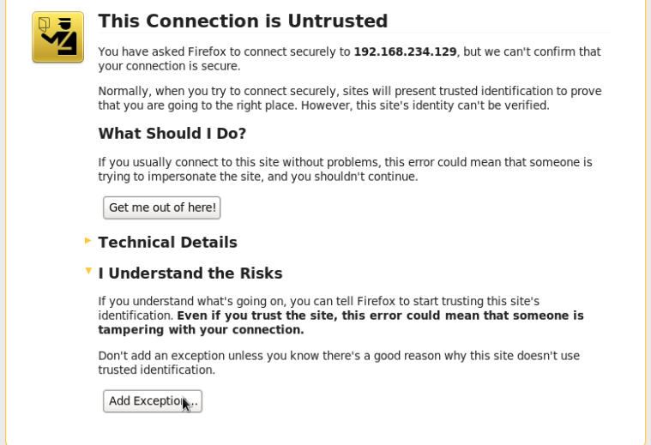

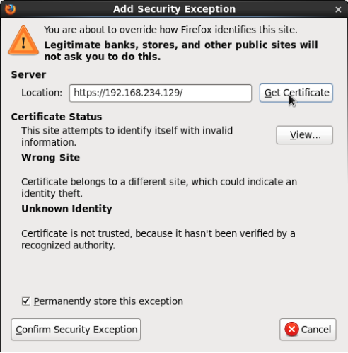

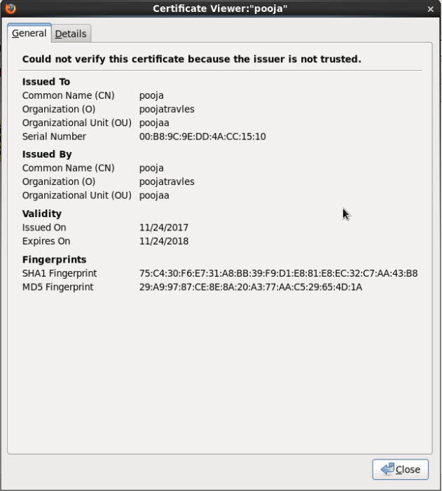

Sign: ______

**Practical 3**

**Aim:** using GnuPGP

**Requirement:** GnuPGP : Kleopatra.

**Solution :**

Kleopatra shows the full path to your selected signature file.

The option *Input file is a separate signature* is activated since you have signed your original

file (here: *Signed file*) with the input file. Kleopatra will automatically find the associated

signed original file in the same file folder.

The same path is also automatically selected for the *Ouput folder*. It only becomes relevant

however once you are processing more than one file simultaneously.

Confirm the operations with [*Decrypt/Check*].

Following a successful check of the signature, the following window appears:

**Create certificate in kleopatra**

For creating certificate: encrypt and decryption

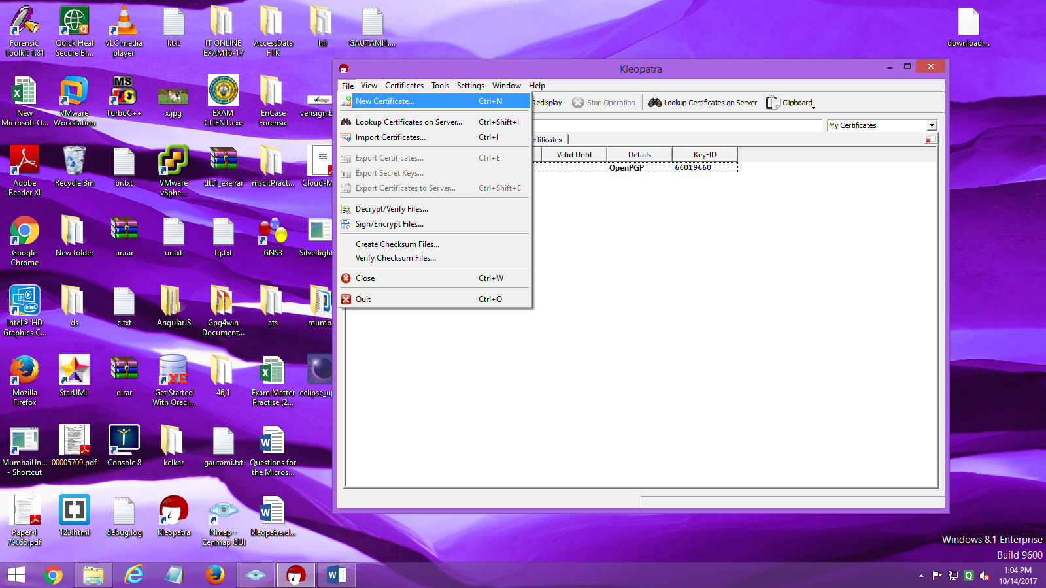

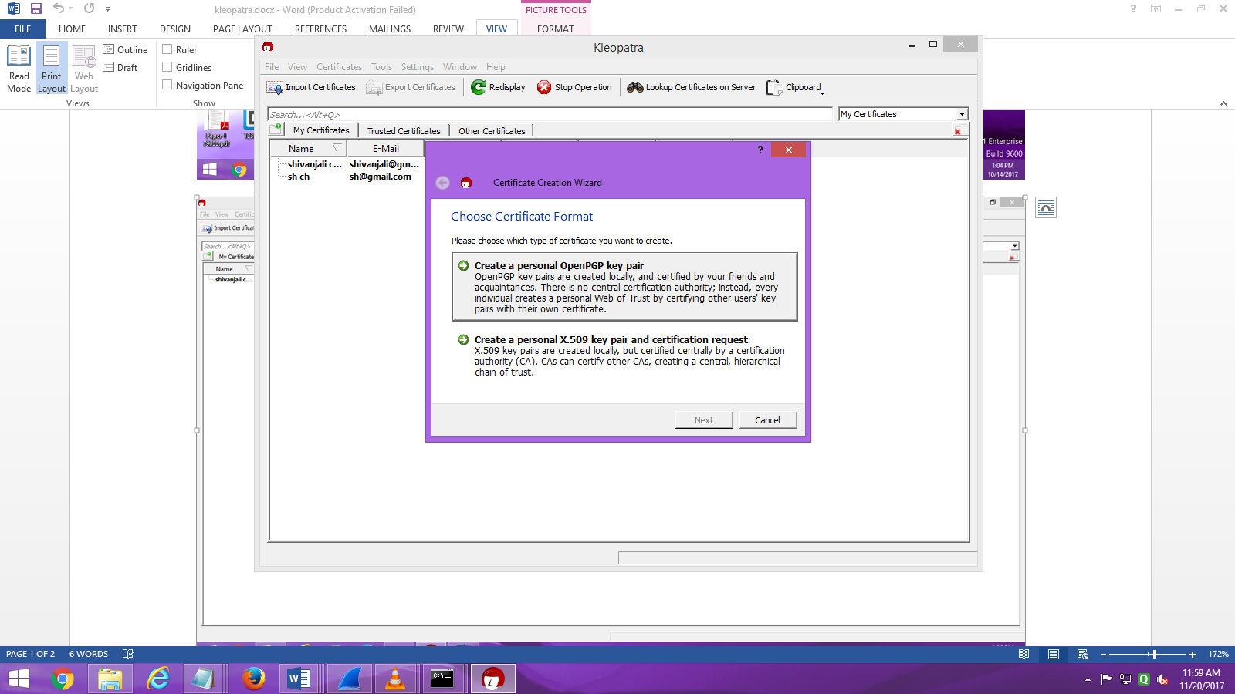

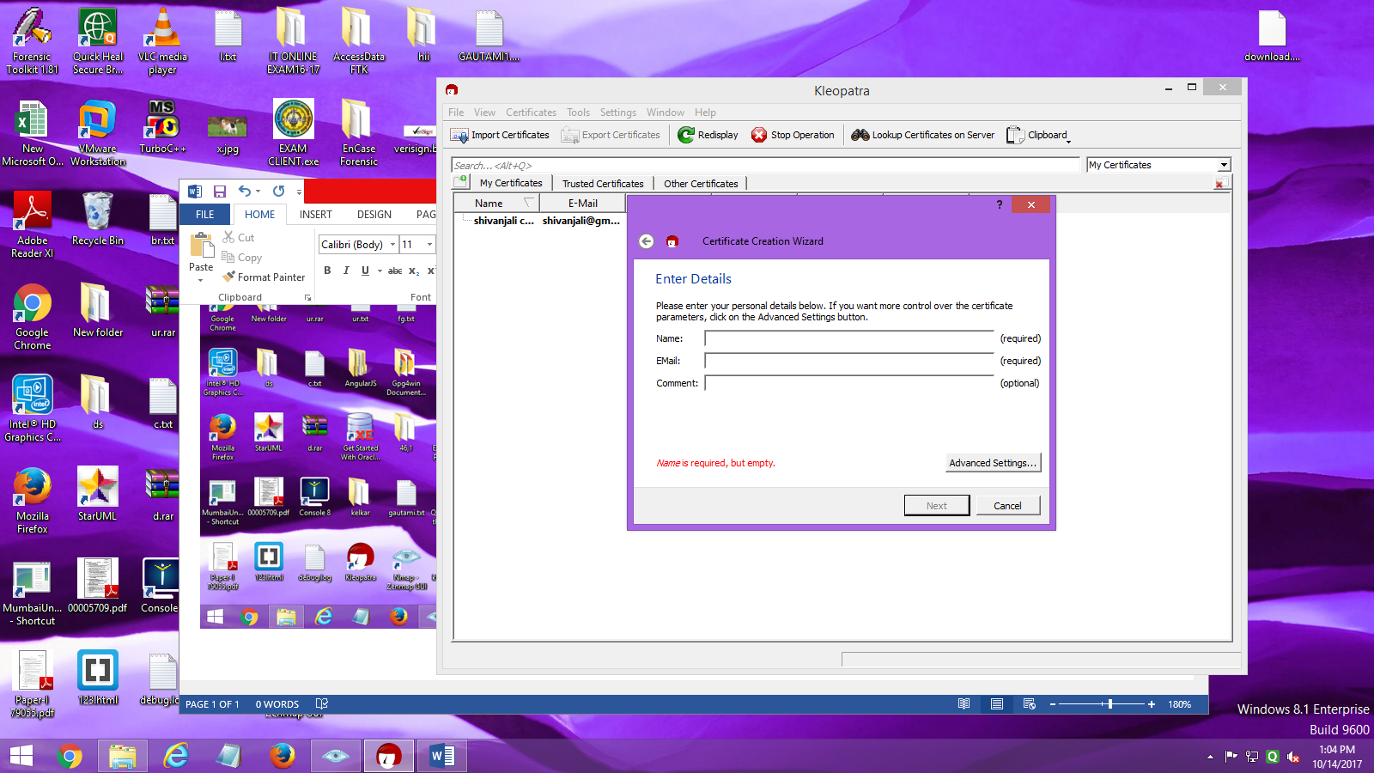

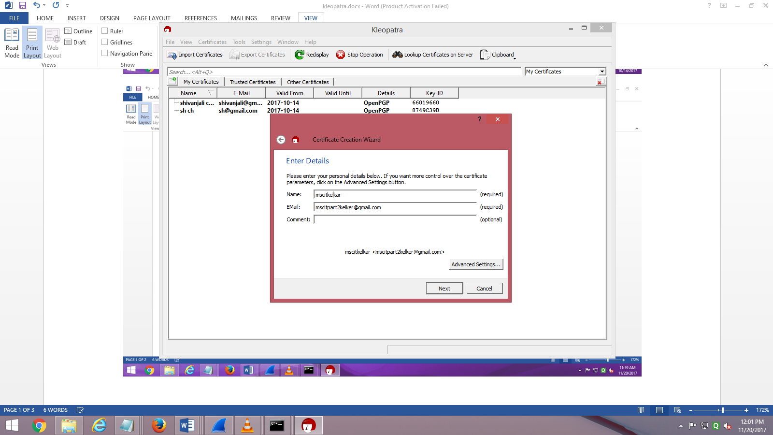

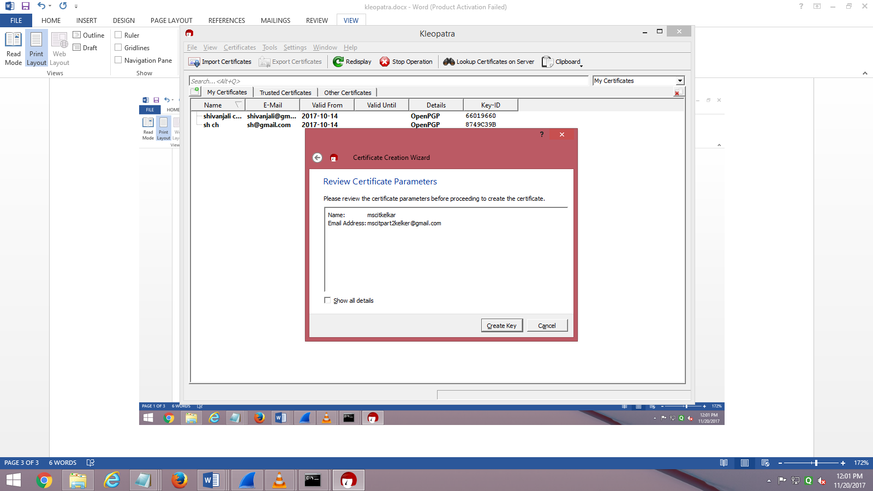

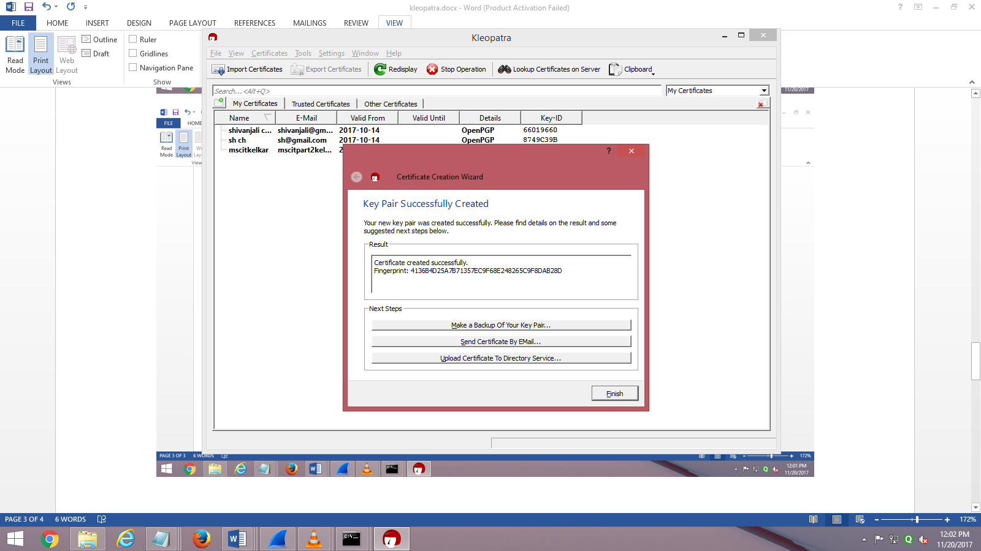

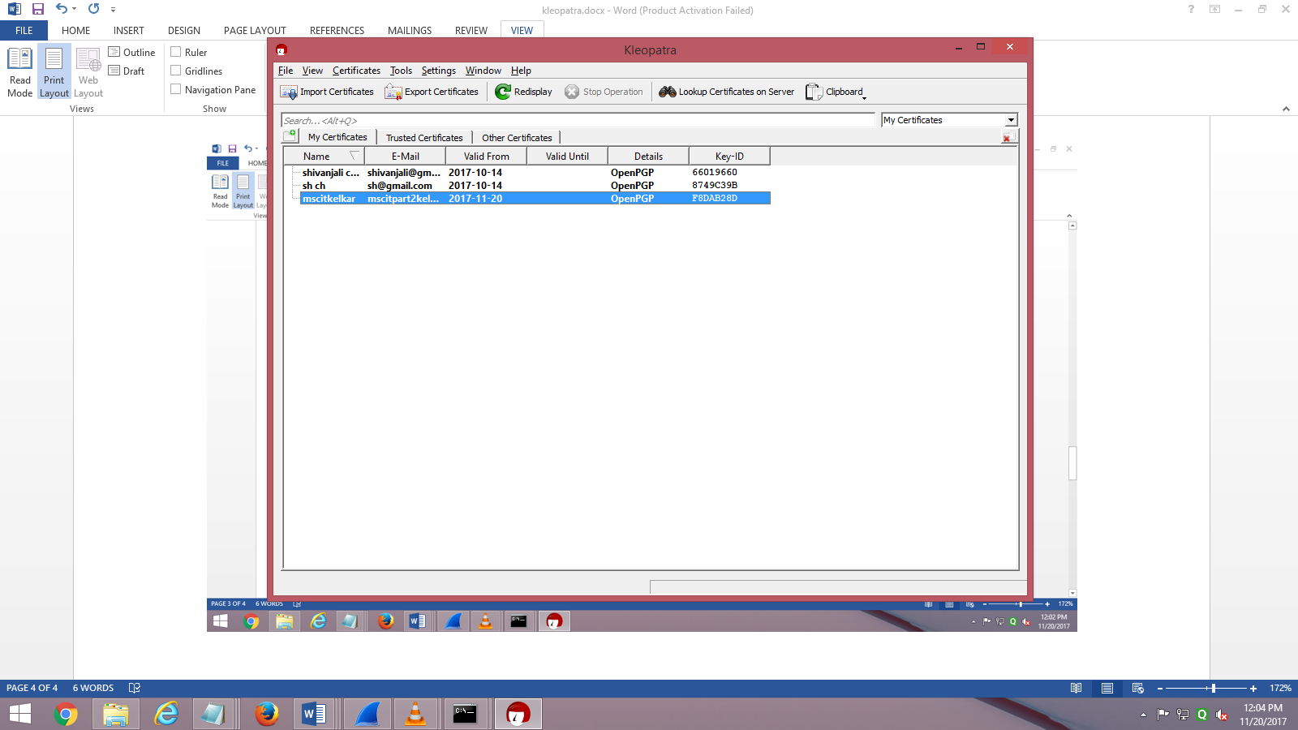

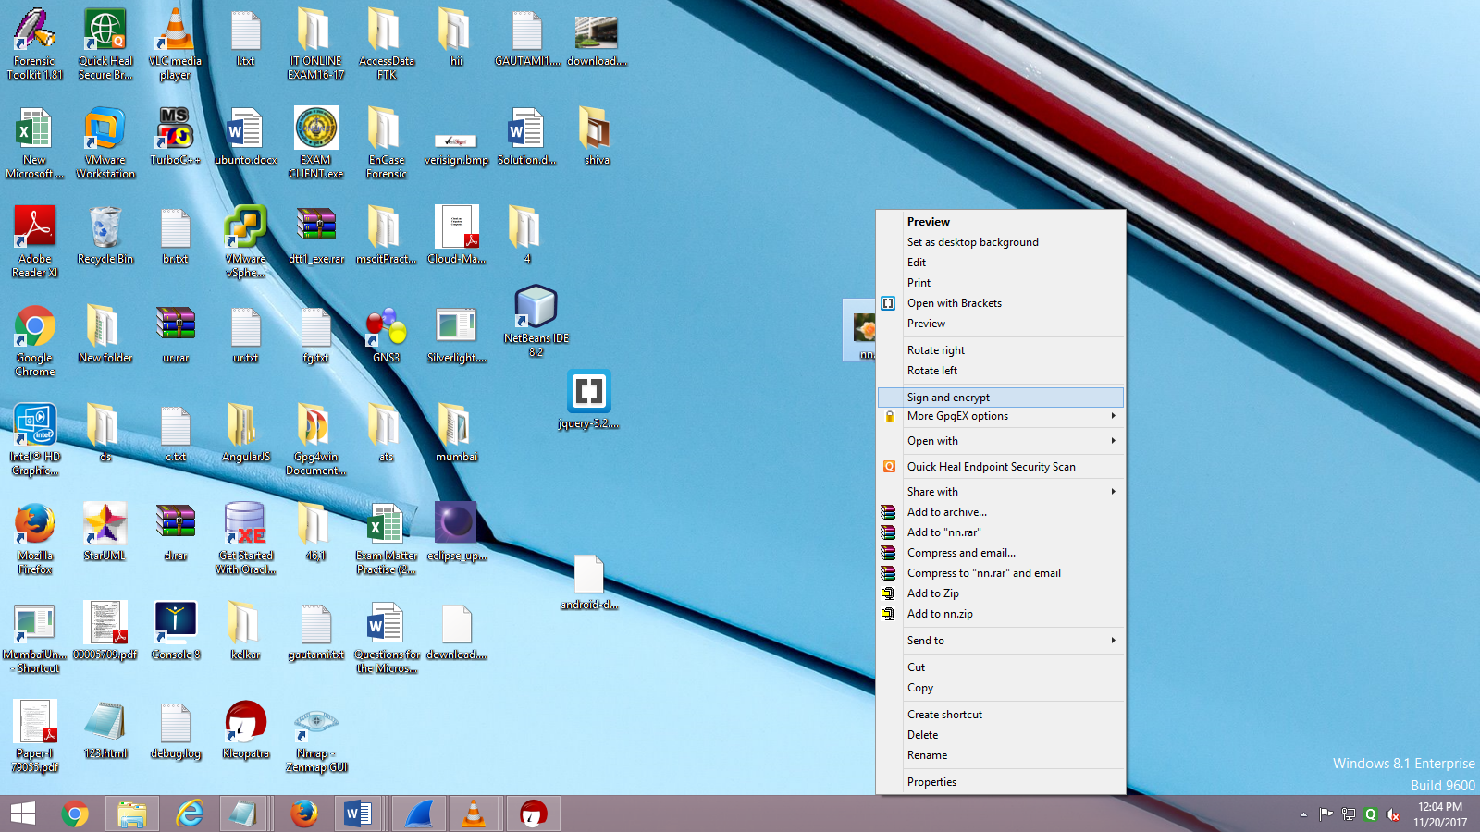

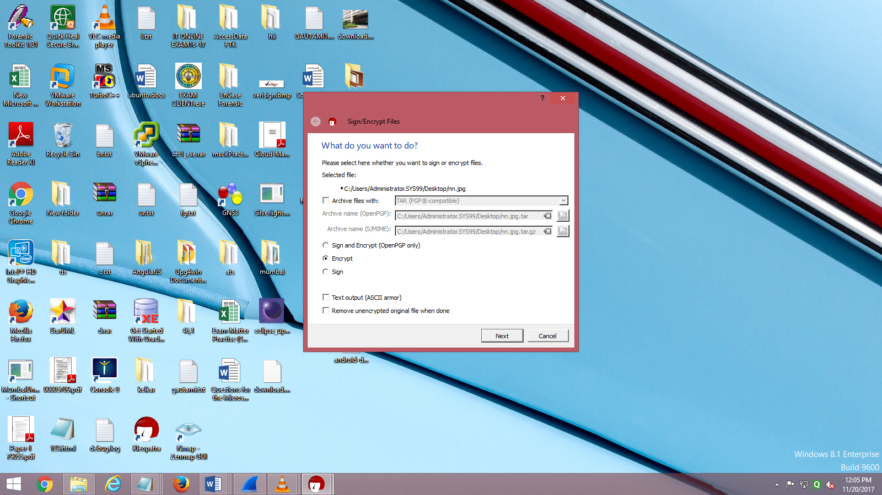

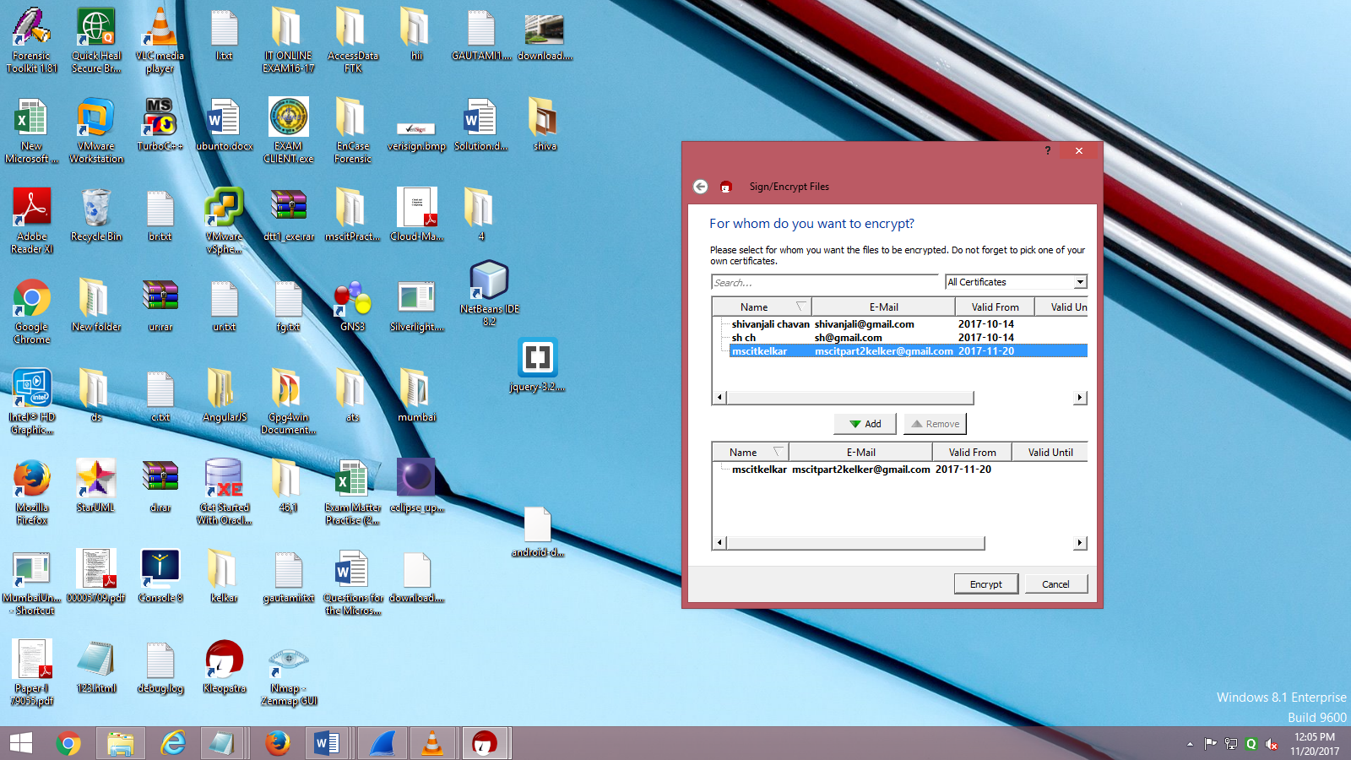

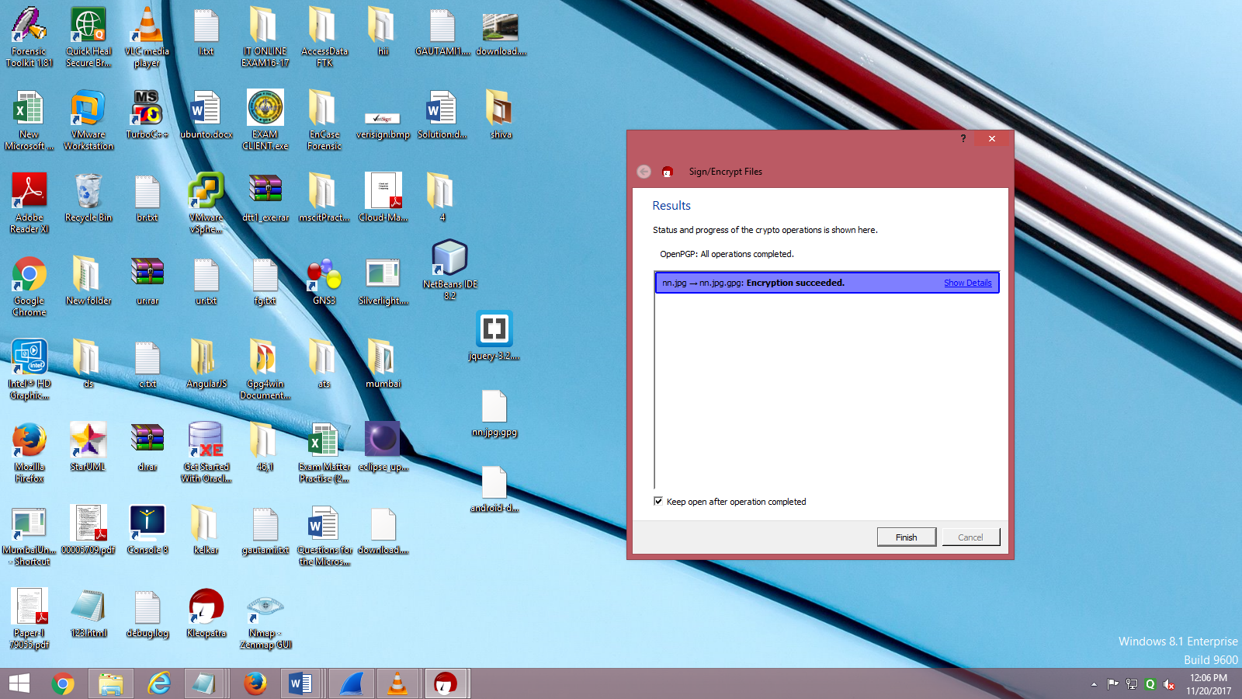

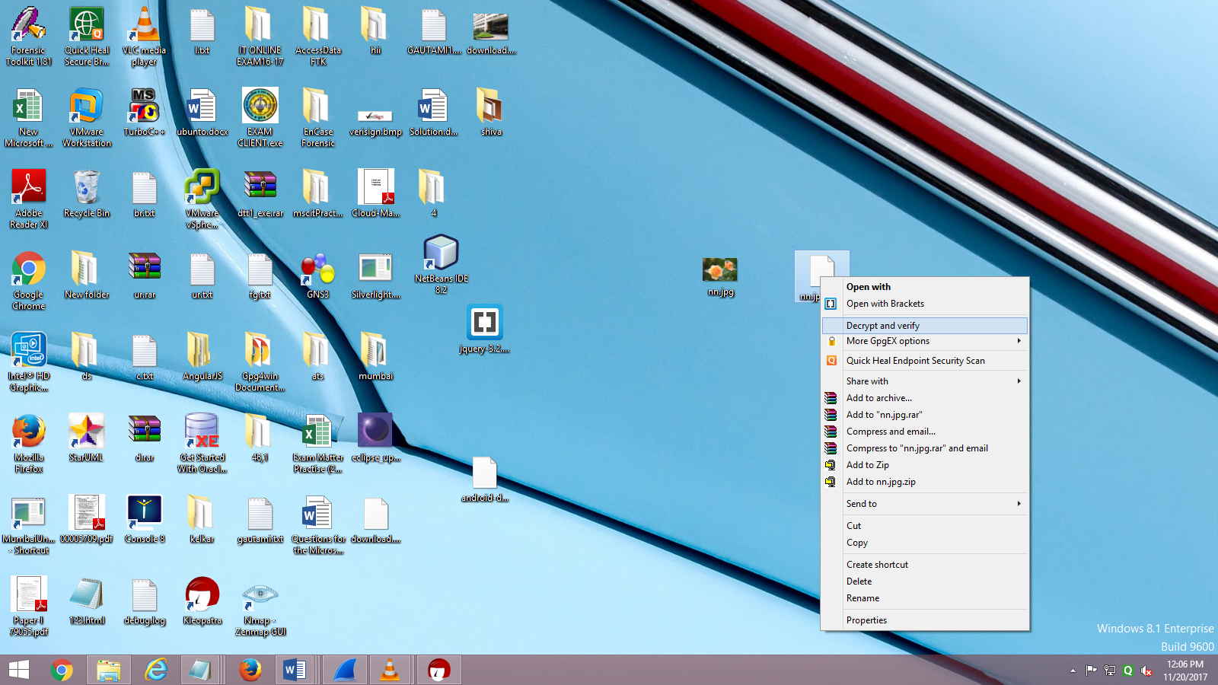

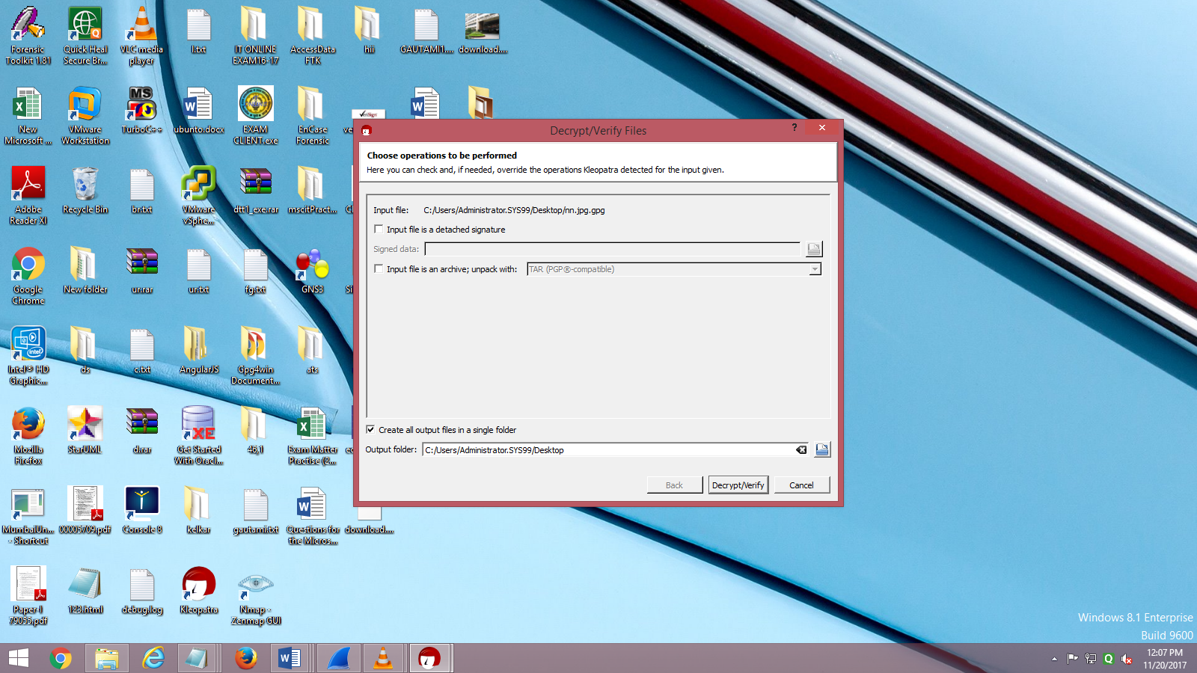

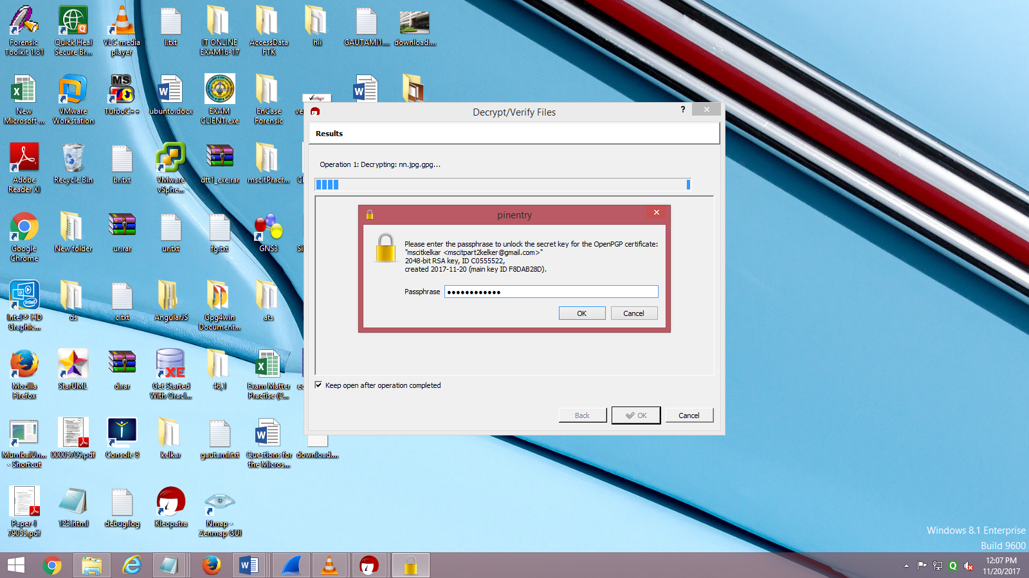

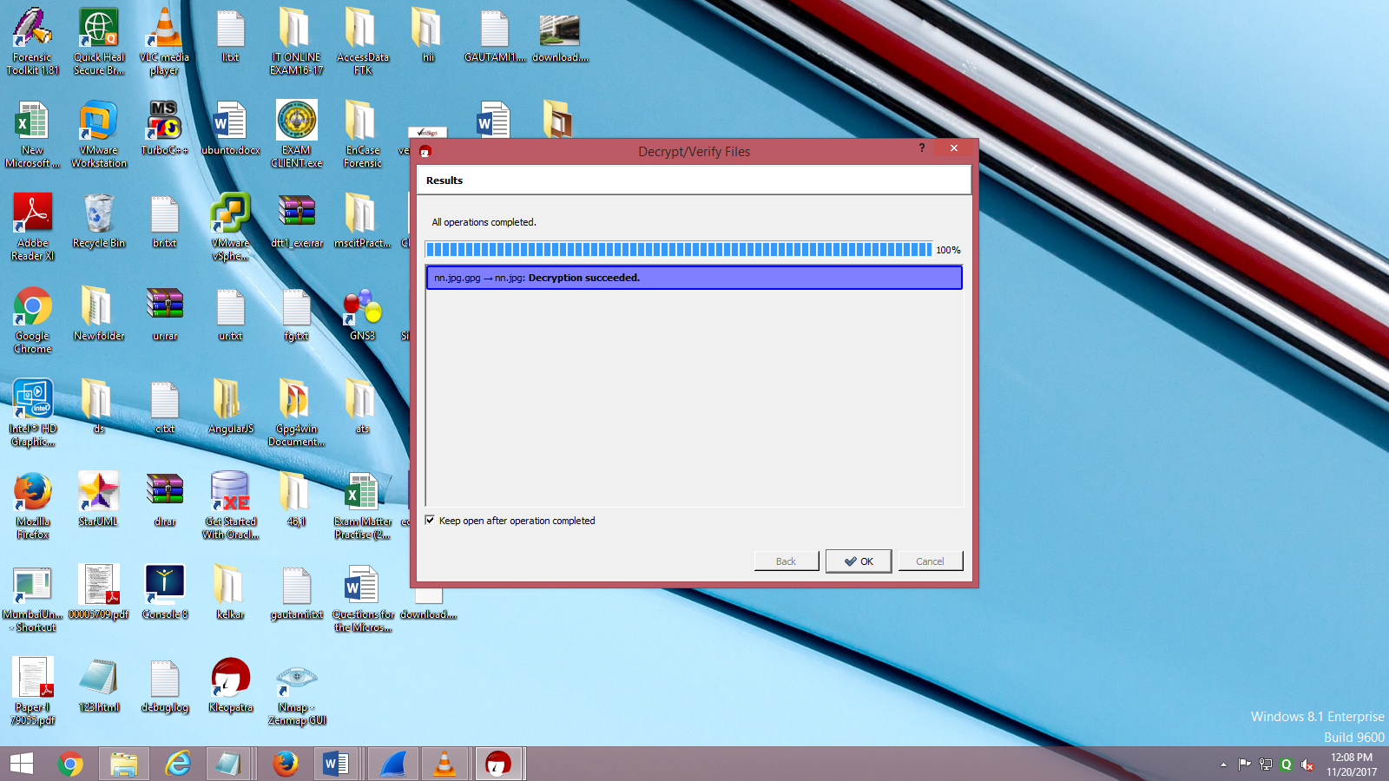

Sign:_______

**Practical 4**

**Aim:** Performance evaluation of various cryptographic algorithm.

**Requirement:** jdk1.8.

**Theory:**

**Comparing DES and AES.**

|  |  |  |
| --- | --- | --- |
|  | **DES** | **AES** |
| Developed | 1977 | 2000 |
| Key Length | 56 bits | 128, 192, or 256 bits |
| Cipher Type | Symmetric block cipher | Symmetric block cipher |
| Block Size | 64 bits | 128 bits |
| Security | Proven inadequate | Considered secure |

**Solution:** Cryptographic algorithms: AES, DES.

**AES:**

AES SERVER:

import java.net.*;

import java.io.*;

import javax.crypto.Cipher;

import javax.crypto.KeyGenerator;

import javax.crypto.SecretKey;

class AESServer{

public static void main(String args[]) throws Exception{

ServerSocket con = new ServerSocket(6789);

while(true)

{

Socket consoc= con.accept();

BufferedReader msgclient = new BufferedReader(new InputStreamReader(consoc.getInputStream()));

String clientsntnc = msgclient.readLine();

//Blowfish

KeyGenerator keygenerator = KeyGenerator.getInstance("AES");

SecretKey secretkey = keygenerator.generateKey();

Cipher cipher = Cipher.getInstance("AES");

cipher.init(Cipher.ENCRYPT_MODE, secretkey);

byte[] encrypted = cipher.doFinal(clientsntnc.getBytes());

cipher.init(Cipher.DECRYPT_MODE, secretkey);

byte[] decrypted = cipher.doFinal(encrypted);

String finalmsg= decrypted.toString();

//send data to client

DataOutputStream oserv = new DataOutputStream(consoc.getOutputStream());

oserv.writeBytes(decrypted + "\n");

}

}

}

AES CLIENT:

import java.io.*;

import java.net.*;

class AESClient {

public static void main(String arg[]) throws Exception {

Socket cSoc = new Socket("localhost",6789);

// Sending value to the server

DataOutputStream oserv = new DataOutputStream(cSoc.getOutputStream());

BufferedReader inUser = new BufferedReader(new InputStreamReader(System.in));

String sntnc = inUser.readLine();

oserv.writeBytes(sntnc + "\n");

//Receiving value from the server

BufferedReader msgclient = new BufferedReader(new InputStreamReader(cSoc.getInputStream()));

String mssg= msgclient.readLine();

System.out.println(mssg);

cSoc.close();

}

}

Output:

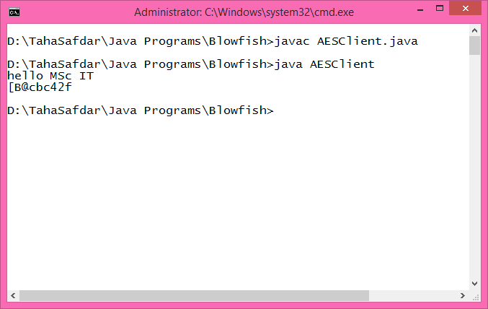

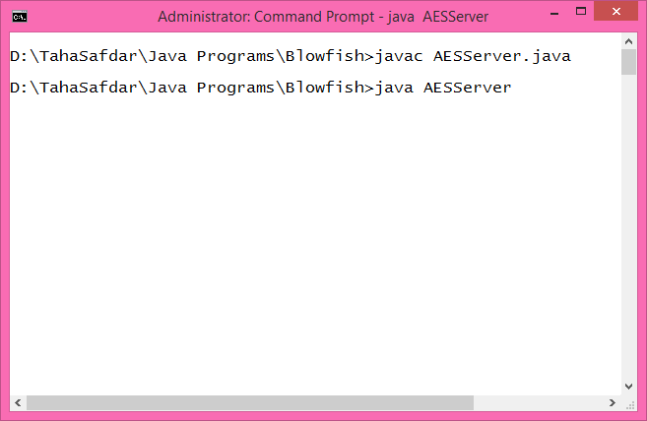

**DES:**

DES SERVER:

import java.net.*;

import java.io.*;

import javax.crypto.Cipher;

import javax.crypto.KeyGenerator;

import javax.crypto.SecretKey;

class DESServer{

public static void main(String args[]) throws Exception{

ServerSocket con = new ServerSocket(6789);

while(true)

{ Socket consoc= con.accept();

BufferedReader msgclient = new BufferedReader(new InputStreamReader(consoc.getInputStream()));

String clientsntnc = msgclient.readLine();

//System.out.println("Received : " + clientsntnc);

//Blowfish

KeyGenerator keygenerator = KeyGenerator.getInstance("DES");

SecretKey secretkey = keygenerator.generateKey();

Cipher cipher = Cipher.getInstance("DES");

cipher.init(Cipher.ENCRYPT_MODE, secretkey);

byte[] encrypted = cipher.doFinal(clientsntnc.getBytes());

cipher.init(Cipher.DECRYPT_MODE, secretkey);

byte[] decrypted = cipher.doFinal(encrypted);

String finalmsg= decrypted.toString();

DataOutputStream oserv = new DataOutputStream(consoc.getOutputStream());

oserv.writeBytes(decrypted + "\n");

}

}

}

DES CLIENT:

import java.io.*;

import java.net.*;

class DESClient {

public static void main(String arg[]) throws Exception {

Socket cSoc = new Socket("localhost",6789);

// Sending value to the server

DataOutputStream oserv = new DataOutputStream(cSoc.getOutputStream());

BufferedReader inUser = new BufferedReader(new InputStreamReader(System.in));

String sntnc = inUser.readLine();

oserv.writeBytes(sntnc + "\n");

//Receiving value from the server

BufferedReader msgclient = new BufferedReader(new InputStreamReader(cSoc.getInputStream()));

String mssg= msgclient.readLine();

System.out.println(mssg);

cSoc.close();

}

}

Output:

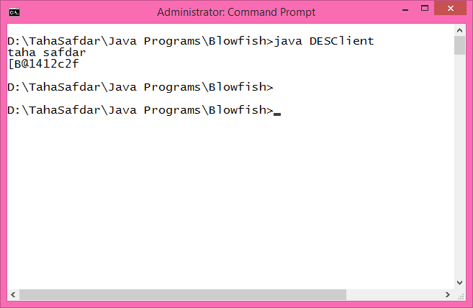

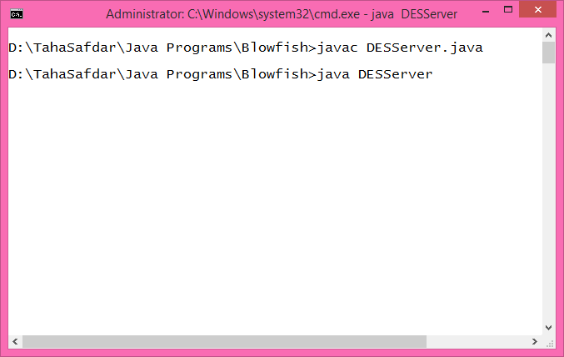

**Result: AES is better than DES.**

Sign_________

**Practical 5**

**Aim:** Using IP TABLES on Linux and setting the filtering rules.

**Requirement:** ubuntuX virtual machine.

**Solution :**

Open new virtual machine ubuntuX.

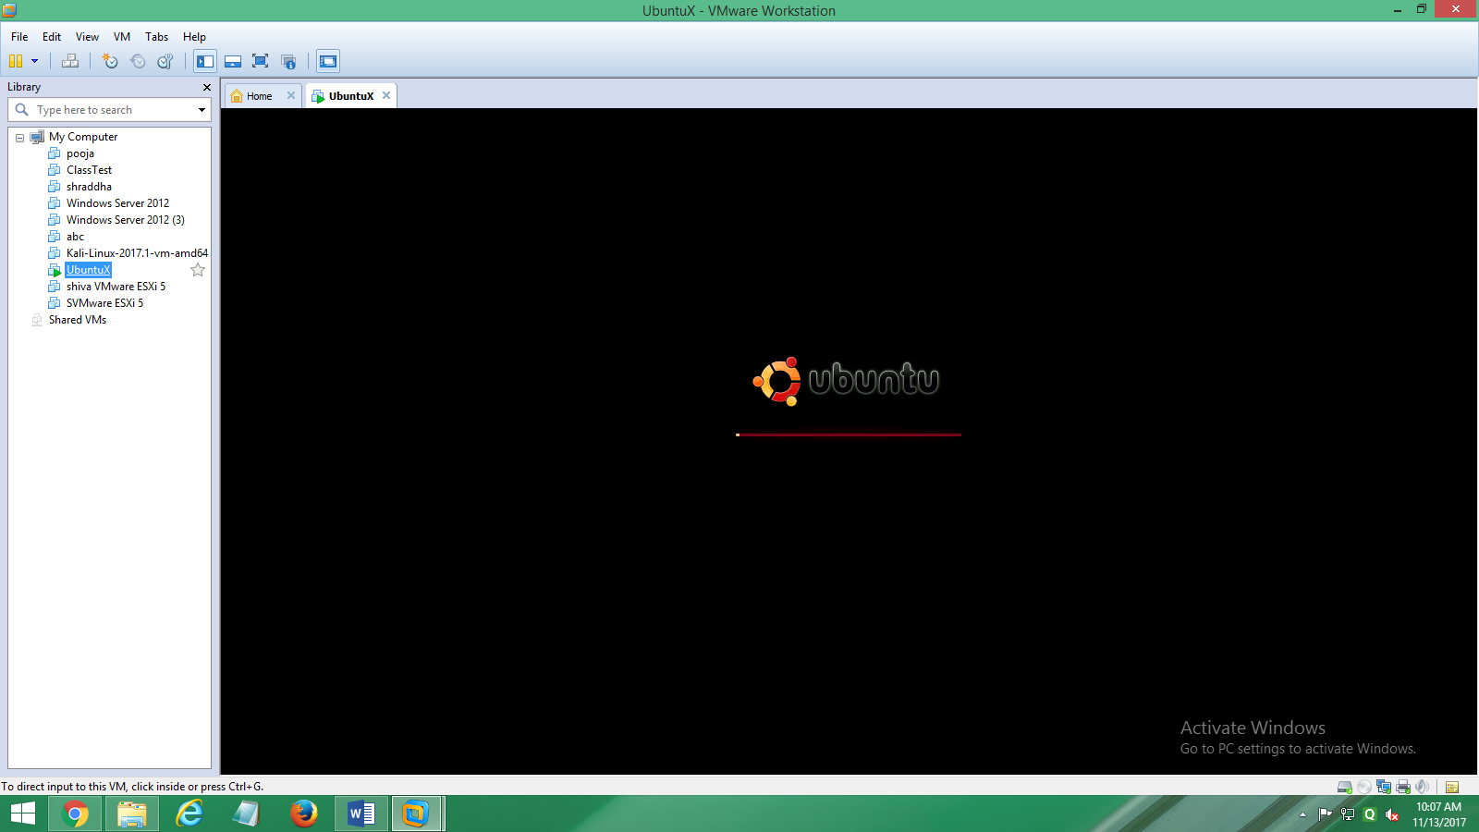

Open the terminal

Path: Application-Accessories-terminal.

Right the command to show the different policies of iptables.

Command: sudo iptables –L

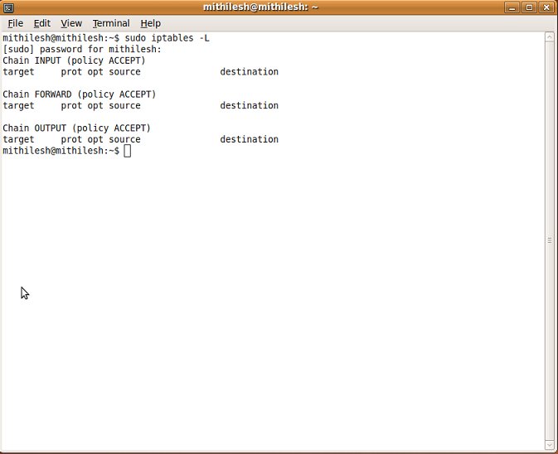

**Step1:**

Allowing incomming traffic on specific port.

Command: sudo iptables -A INPUT -p tcp --dport ssh -j ACCEPT

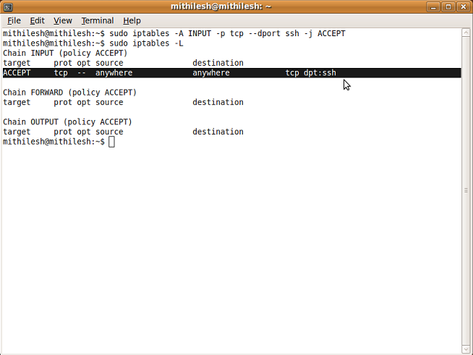

**Step2:**

Allowing to establish a session

Command: sudo iptables -A INPUT -m conntrack - -ctstate ESTABLISHED,RELATED -j ACCEPT

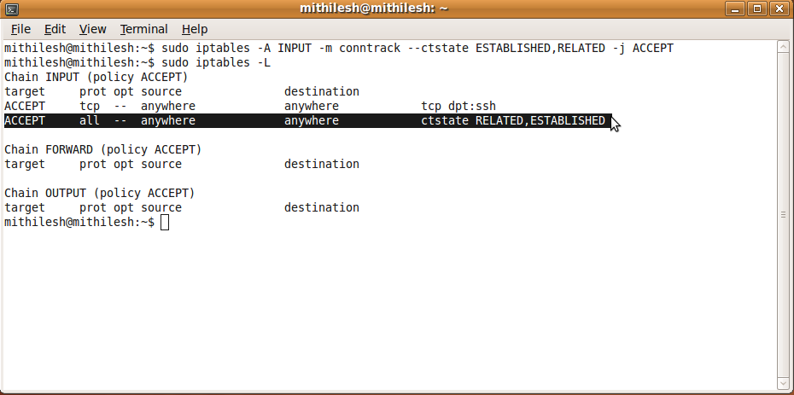

**Step3:**

Set default policies for iptables, filter tables using -P flag. (-P transfer the police)

Command: sudo iptables -t filter -P OUTPUT DROP.

sudo iptables -t filter -P INPUT DROP.

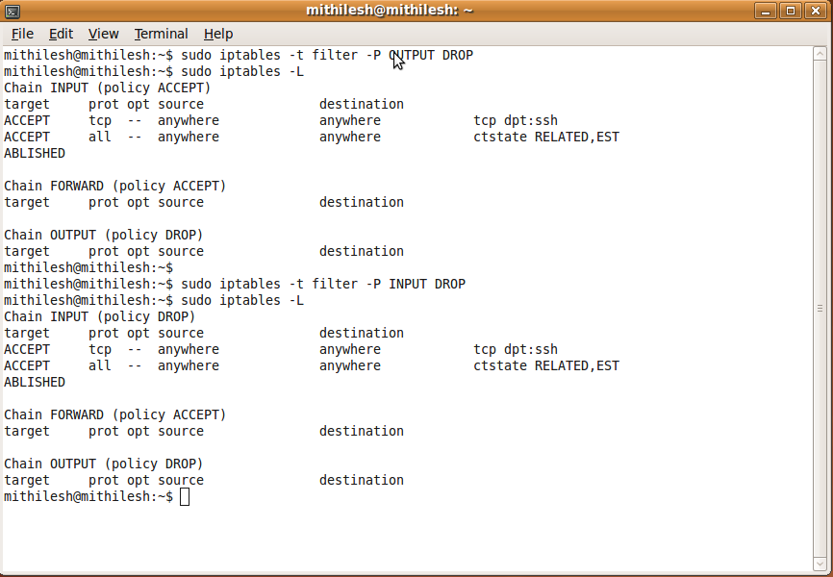

**Step4:**

If you need to disable firewall on temporary basis you can flush all the rules by using command.

Command: sudo iptables -t filter -P INPUT ACCEPT.

sudo iptables -t filter -P OUTPUT ACCEPT.

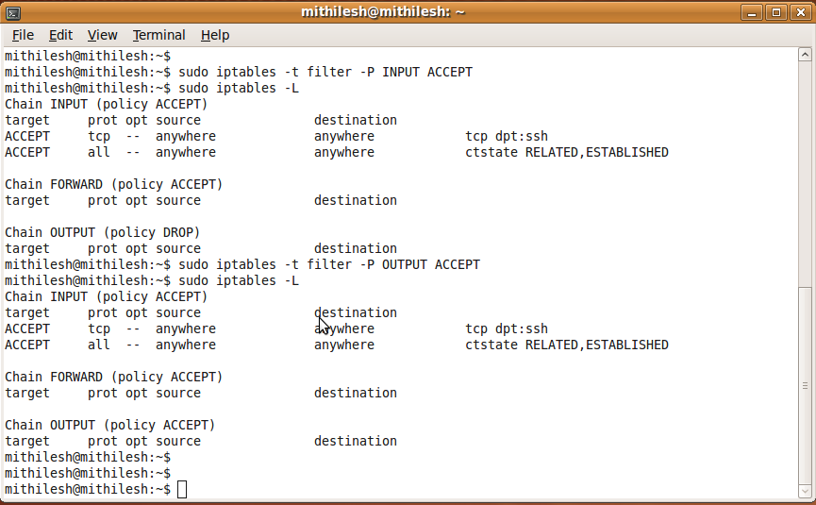

**Step5:**

Allow the machine to send only HTTP request and SSH request.

Command: sudo iptables -A INPUT -p tcp -i eth0 --dport 80.(for HTTP port 80)

sudo iptables -A INPUT -p tcp -i eth0 --dport 22.(for SSH port 22)

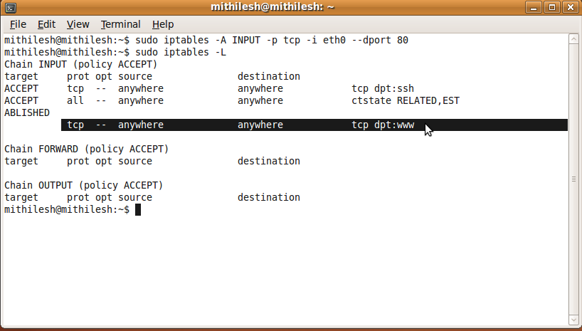

**Step6:**

Allow the incoming traffic for specific port.

Command: sudo iptables -A OUTPUT -p tcp -o eth0 --dport 20.(for ftp data port 20)

sudo iptables -A OUTPUT -p tcp -o eth0 --dport 21.(for ftp port 21)

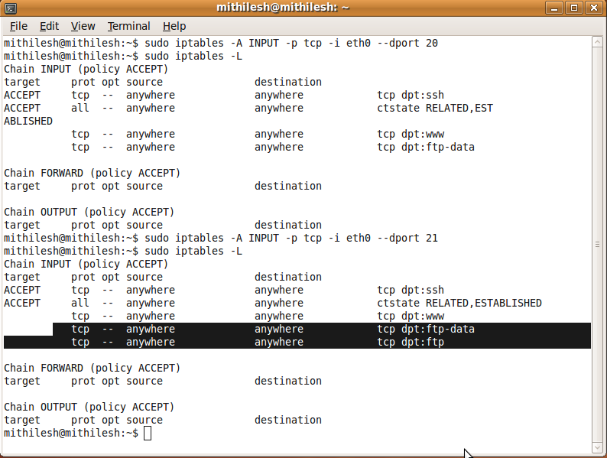

**Step7:**

Allow all traffic from internal LAN

Command:

sudo iptables -A OUTPUT -j ACCEPT -p all -d 192.168.65.22 -o eth0.(to check destination rechability)

sudo iptables -A INPUT -j ACCEPT -p all -s 192.168.65.22 -i eth0.( to check source rechability)

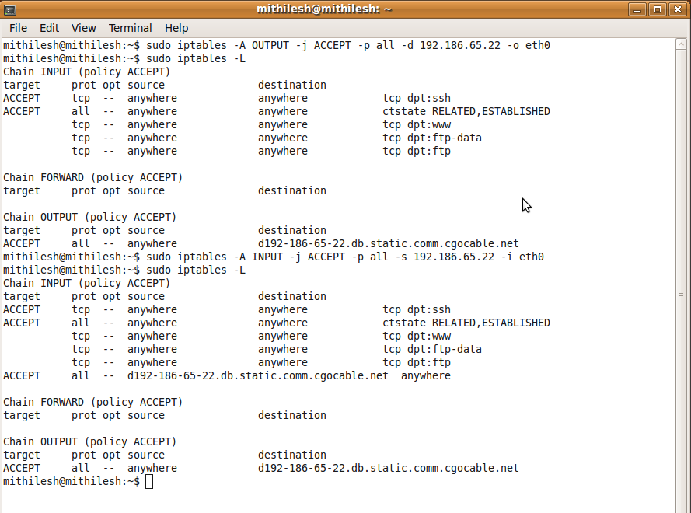

**Step 8:**

Editing iptables

Command: sudo iptables -I INPUT -i 10 -j ACCEPT

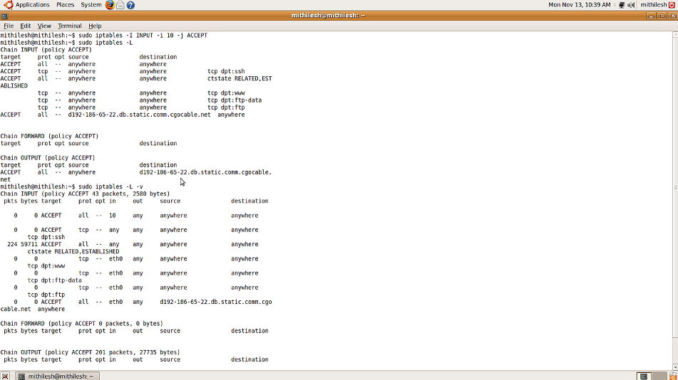

**Step 9:**

To save iptables configuration

Command:sudo su(it redirected to the root)

iptables-save > fileName.txt.(it create new file in root folder.)

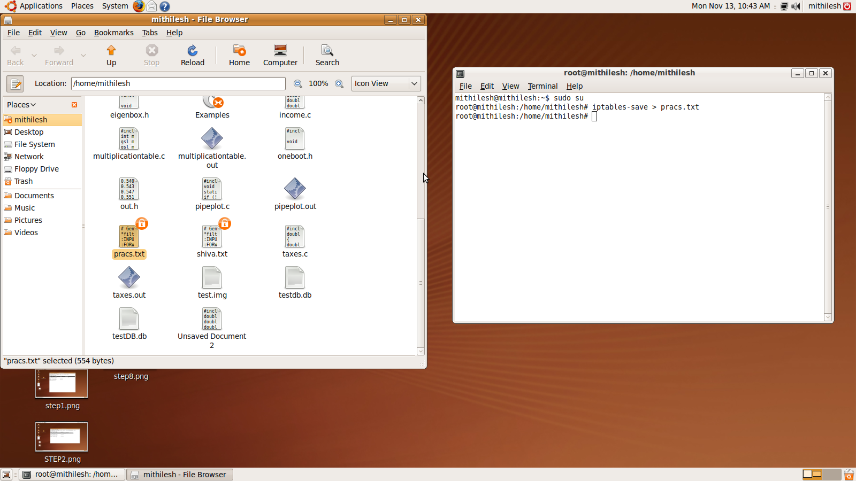

Sign:________

**Practical 6**

**Aim:** Working with S/mime with MS outlook.

**Requirement:** Gmail account, Outlook 2010 / 2013, Comodo free certificate website ([*https://www.comodo.com/home/email-security/free-email-certificate.php*](https://www.comodo.com/home/email-security/free-email-certificate.php) )

**Solution:**

**Step 1:**

1. Open your gmail account.

2. Go to setting option.

3. Then go to forwarding and POP/IMAP tab. Click on enable POP for all mail and enable IMAP radiobutton.

4. Scroll down and save the changes.

5. Go to my account, click on sign-in & security.

6. Allow the less secure apps: ON

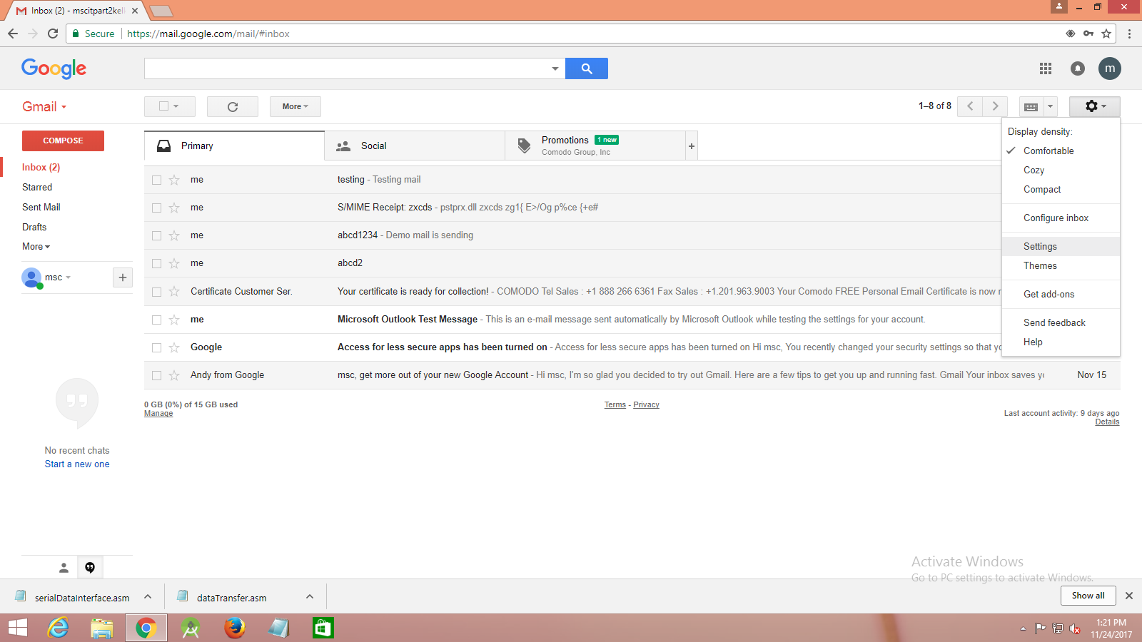

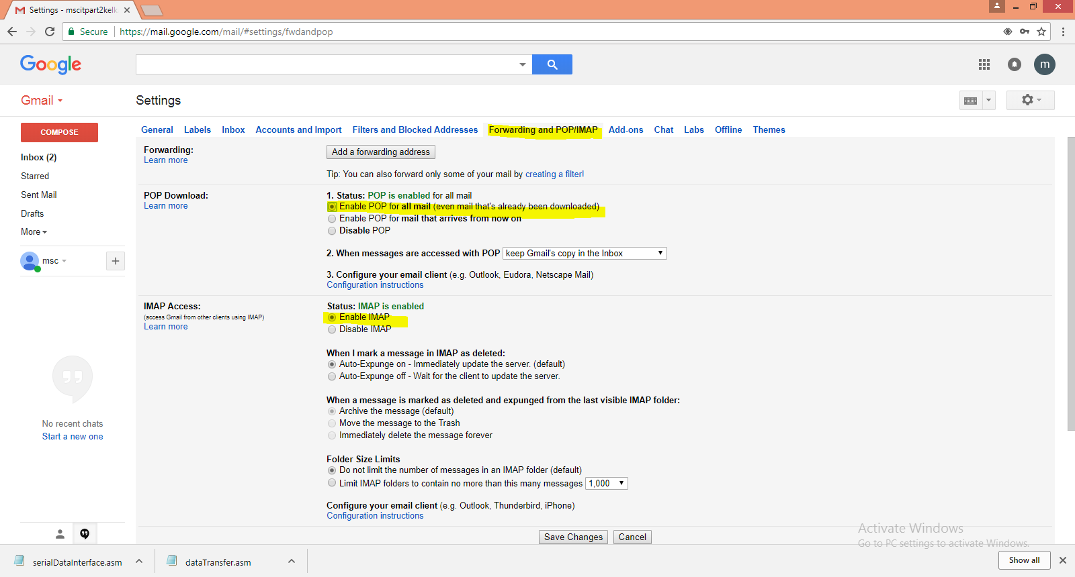

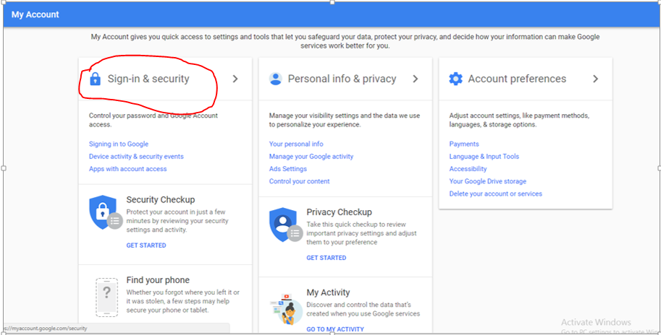

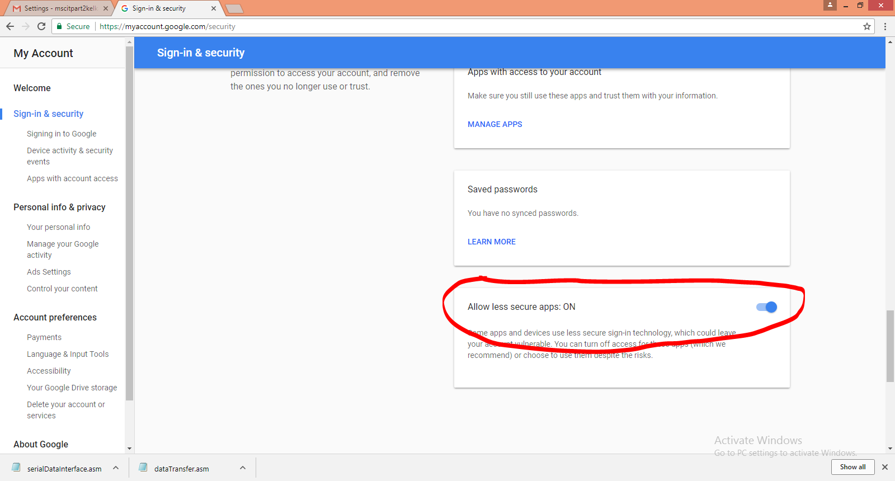

**Step 2:**

1.Go to Start->control panel->user account &Family Safety->mail.

2. Click on email account.

3. Go to email ->new-> add account.

Here select manually configure server setting or additional server types radiobutton and click on next button.

4. Enable POP or IMAP.

5. Choose service as Internet E-mail. Click on add button

Fill the information ....

åccount type: IMAP

Incoming mail server: imap.gmail.com

Outgoing mail server:smtp.gmail.com

and click on More Settings button.

6. Go to "Outgoing Server" tab and select the checkbox "My outgoing server requires authentication".

7. Go to "Advanced" tab and provide port numbers, type of encryption connection and server timeouts.

IMAP: 993 / ENCRYPTED CONN:SSL

SMTP: 587 /ENCRYPTED CONN:TLS

Click on Ok button.

8. FinaIIy "Test Account Setting" and close this window and click on next button of main

window.

CIick on "Finish" button.

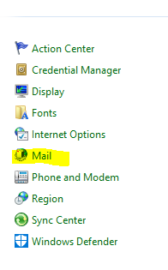

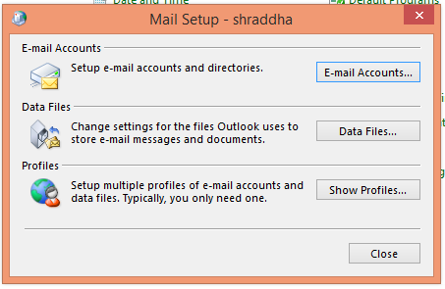

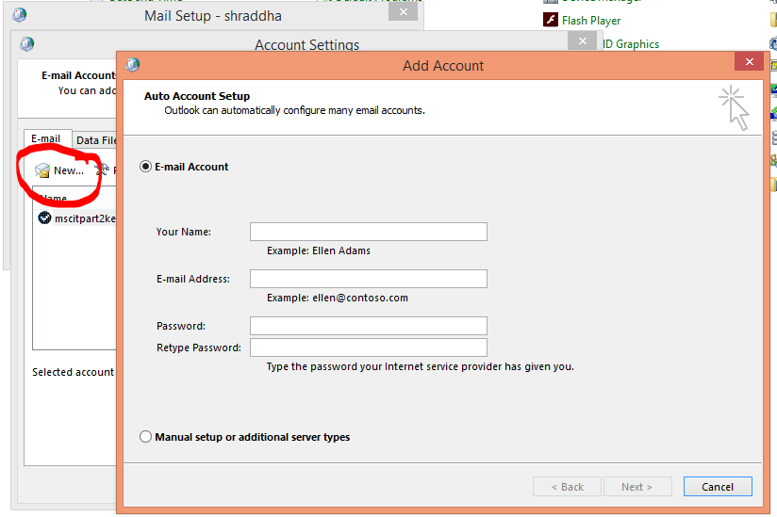

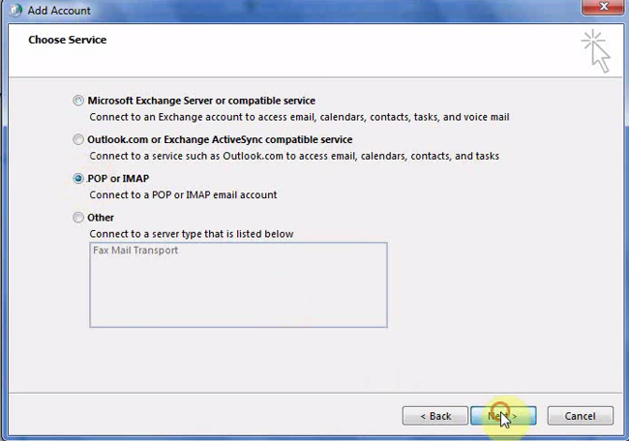

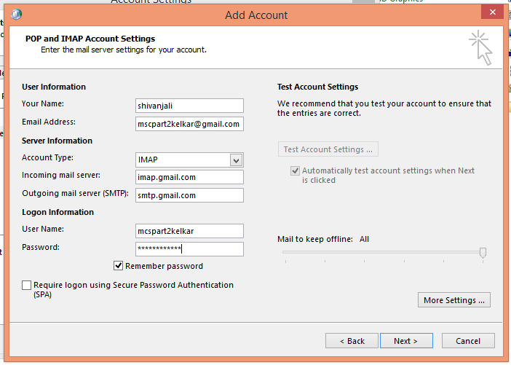

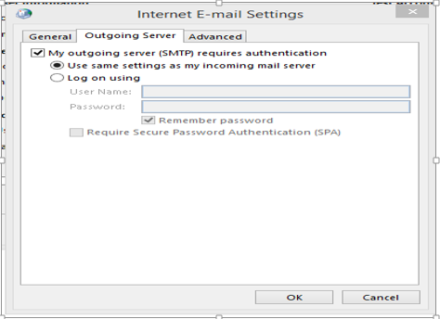

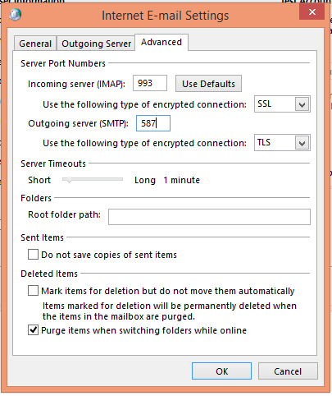

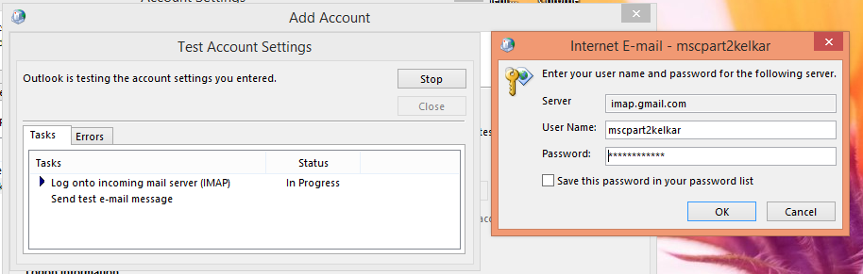

**Step 3:**

1. In browser, type [*www.comodo.com*](http://www.comodo.com)*. Click on free products tab. Or directly go to this link* [*https://www.comodo.com/home/email-security/free-email-certificate.php*](https://www.comodo.com/home/email-security/free-email-certificate.php)

*2. ScroII down, you will get free Email Certificate option.Click on free Download.*

*Here click on free Email certificate button.*

*3. FiII the application. SeIect the checkbox and click on Next button.*

*4. Again switch to gmail account to see the mail for certificate.*

*5. 0pen the "certificate customer* service" mail and click on "click & install comodo mail certificate" button

6. Certificate has been installed.

7. To backup a copy of certificate, go to menu -options in your mozilla browser.

In options, go to Advanced certificate tab. Here click on "view certificate " button.

8. Certificate manager window will get open, here select the certificate and click on backup button.

9.Locate the path where you want to save the certificate file and provide a name also.

Click on save button.

10.Choose a backup password. And click on ok button.

Certificate and private key will get successfully backed up.

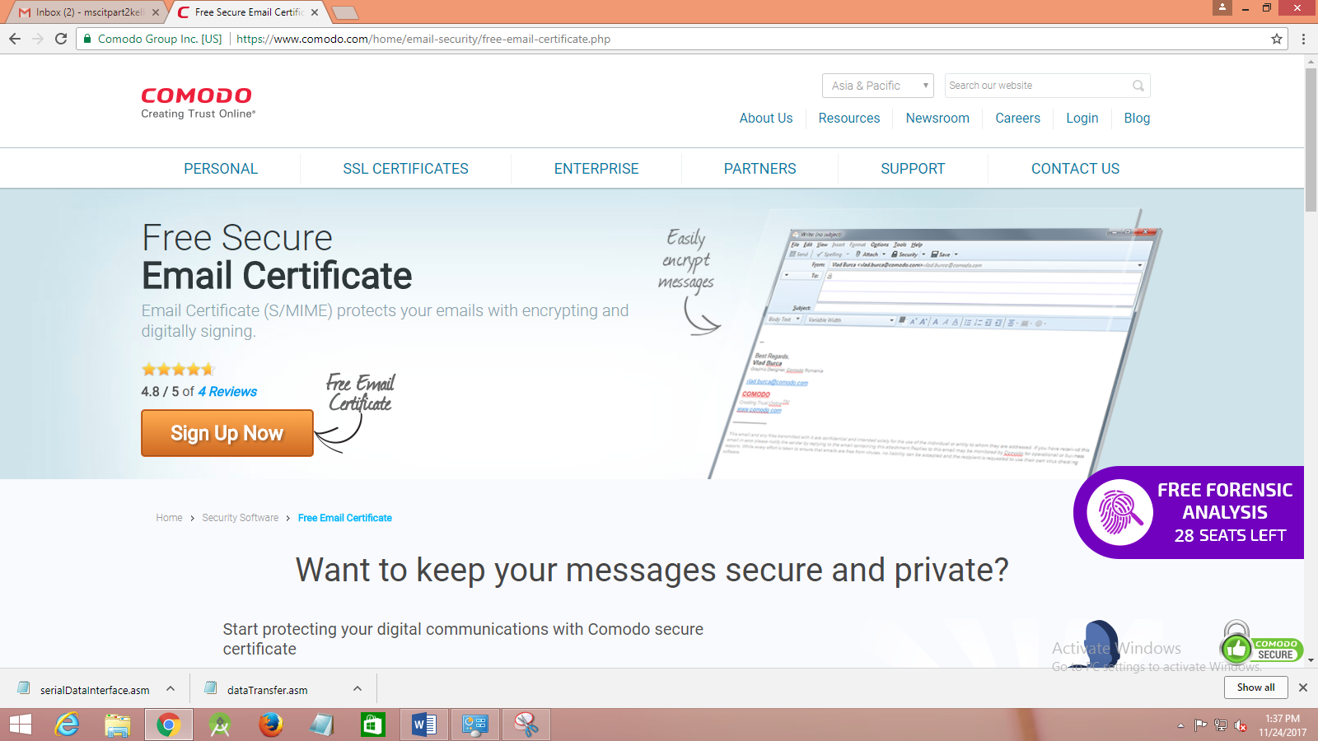

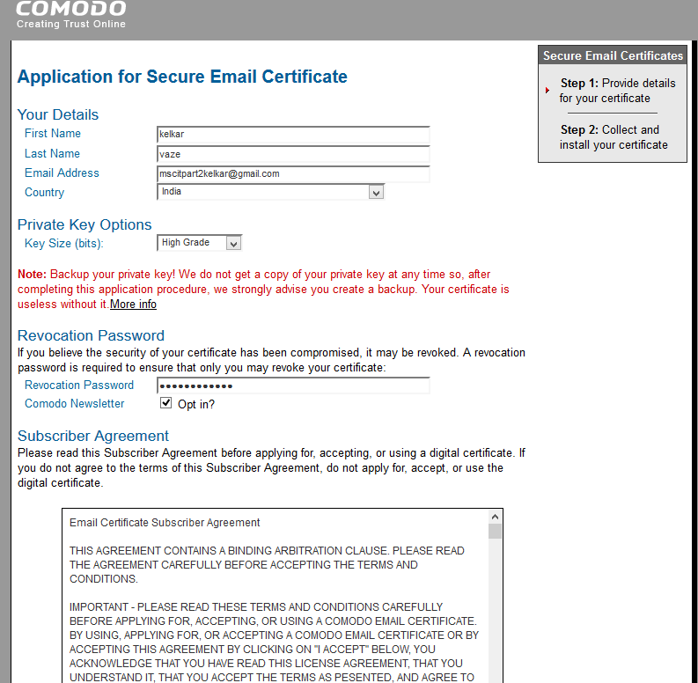

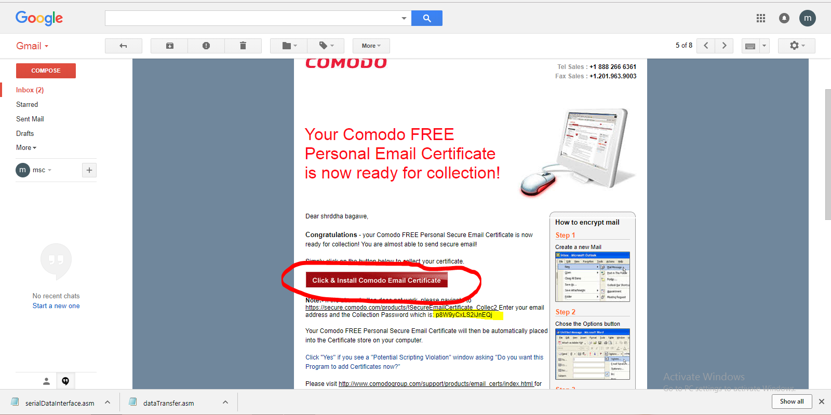

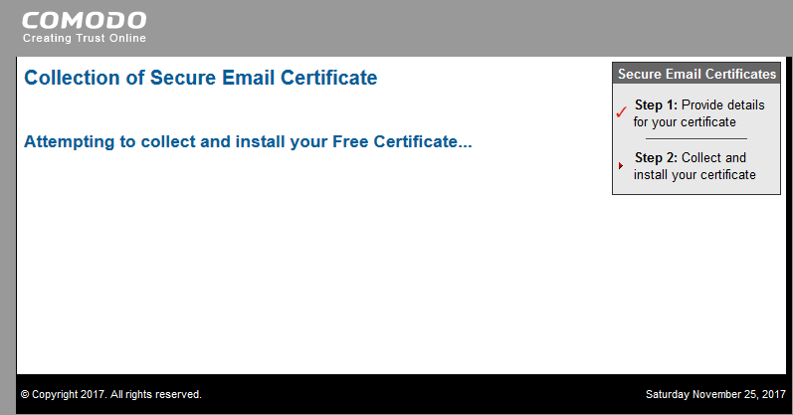

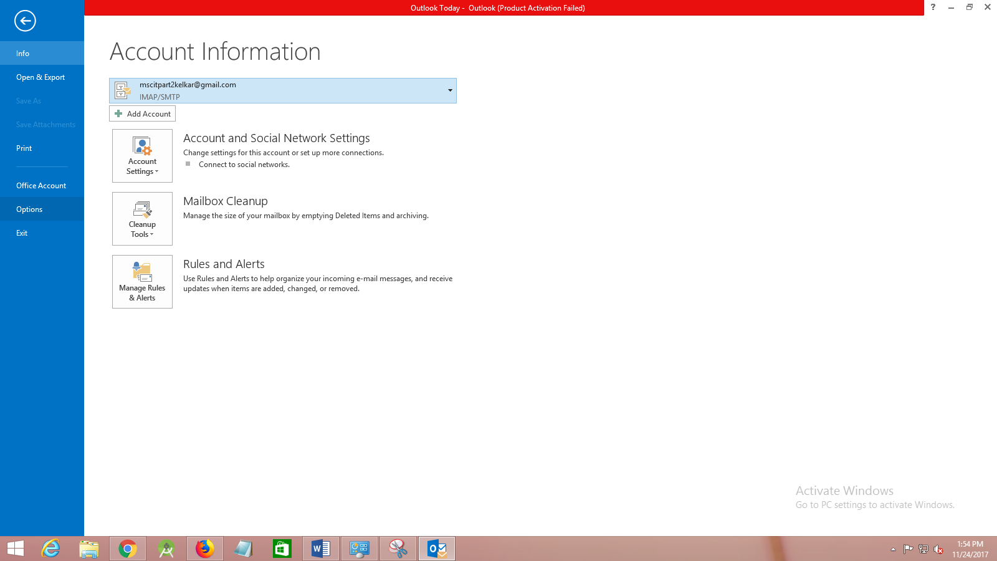

**Step 4:**

Importing your Certificate into Outlook 2010 / 2013:

I. Open Outlook 2010 / 2013, choose profile name and click on OK button.

2. Click 'File' 'Options'.

3.In the Outlook Options screen, click 'Trustcenter' 'Trustcenter Settings'

4.In the Trust Center screen, select 'E-mail Security' then click the 'Import/Export' button.

5.In the Import/Export Digital ID interface, navigate to the location of your PKCS12 certificate file and click 'Open'. Enter the password that was used while exporting the certificate and provide a Digital ID name.CIick 'OK'

6.SeIect the security level for storing the Private Key in your system and click OK.

Signing individual mails:

7 .To sign an individual mail, first compose a new mail or reply to/forward an existing mail.

8. Click 'Options' on the message menu bar then click, 'Sign' .

9. To send the mail click on send button. "Request for permission to a use a key" will get

appear asking to grant or deny this application to use this key so you select

'grant permission" option and click on OK button.

10.Check your mail in outlook / gmail and open it.

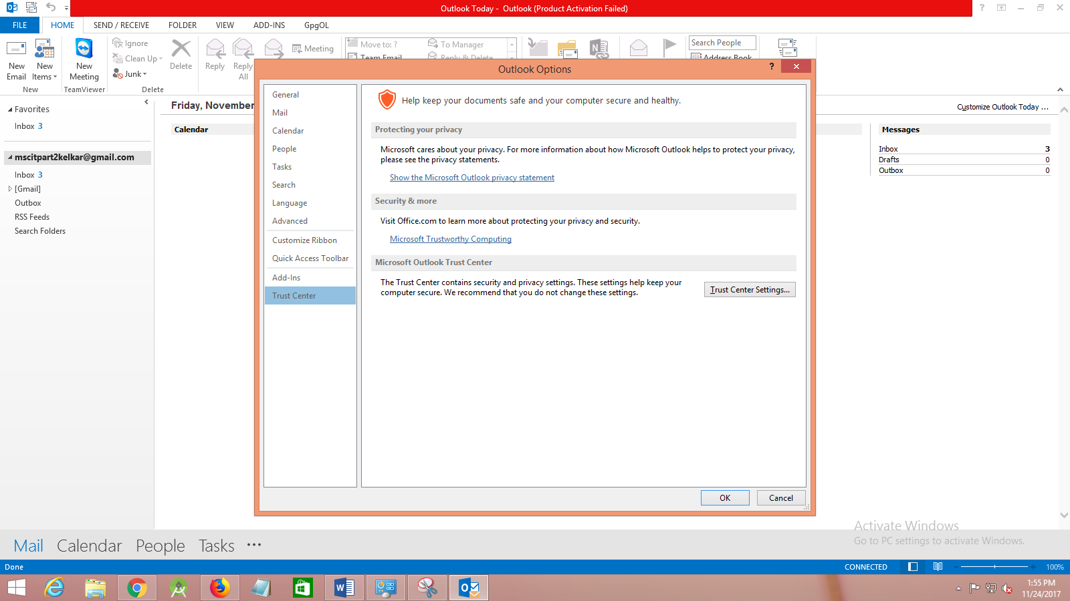

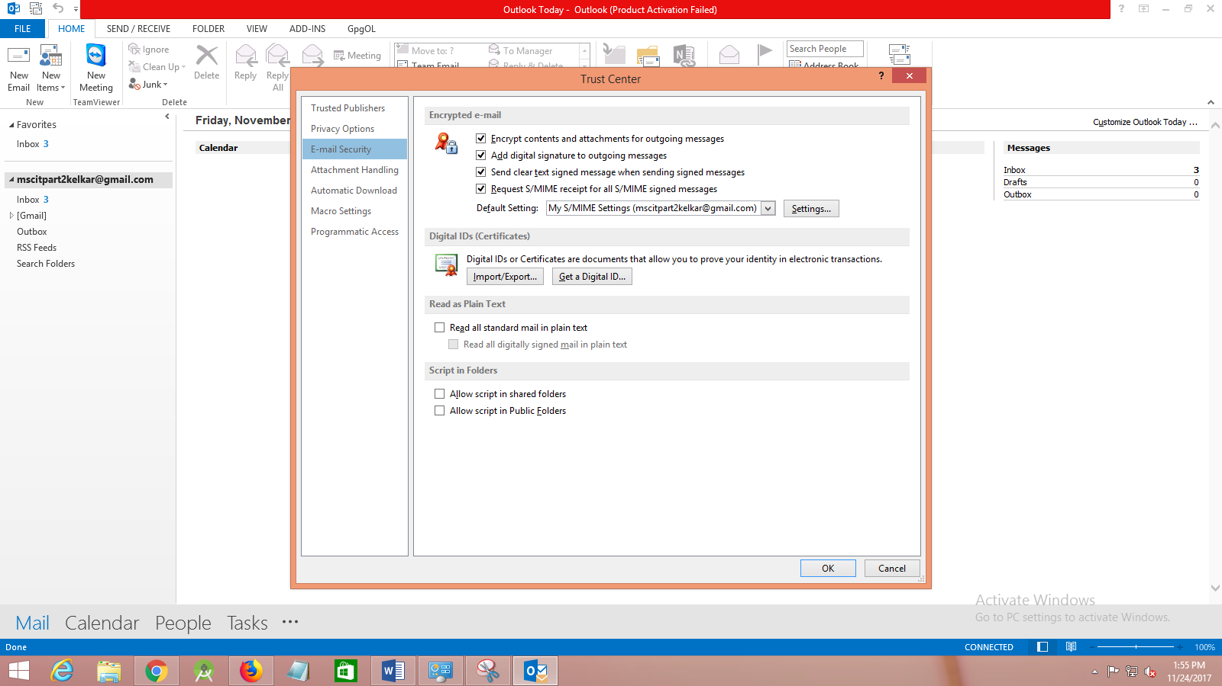

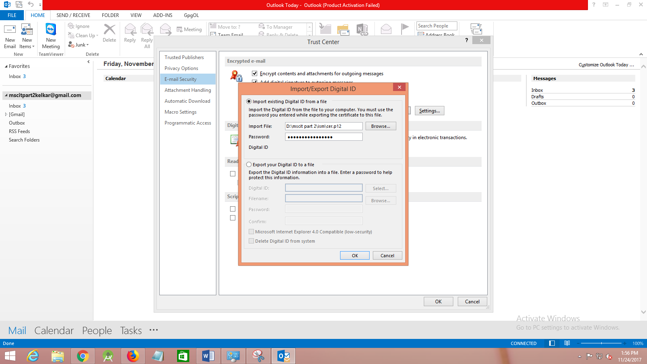

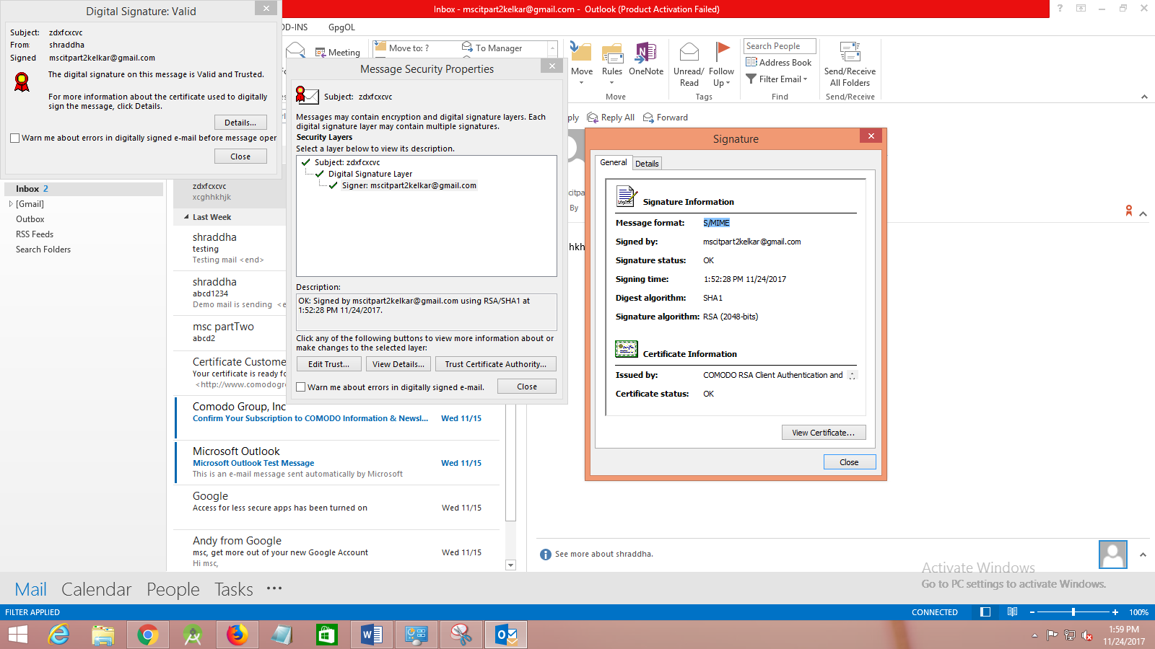

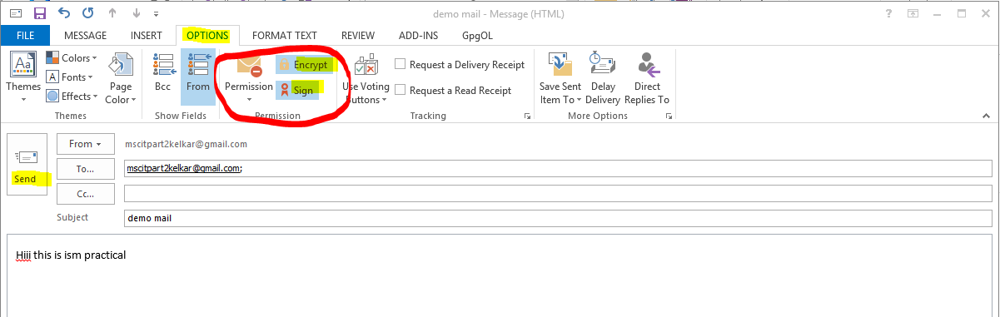

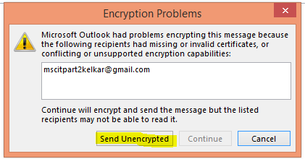

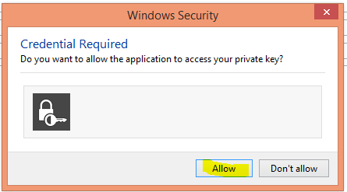

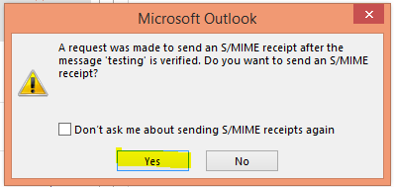

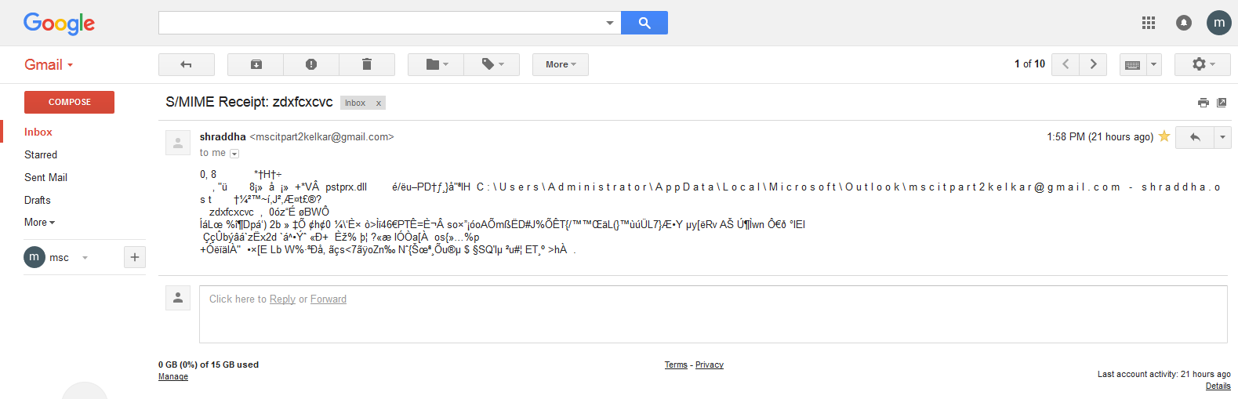

Encrypting an Email:

Encrypting an email ensures that only the recipient may view the email content and

any attachments. Note: in order to encrypt an email for the recipient you must have

the recipient's Digital Certificate, and their digital certificates must be assigned to the

relevant entry in your address book

1. Compose your email and attach files as usual

2. Ensure the recipient has a Digital Certificate and you have assigned the Certificate to

their entry in your Outlook contacts area

3. Click Encrypt button

4. Click Send button

Sign:________

**Practical 7**

**Aim:**

* What is buffer overflow?
* How a buffer overflow happens?
* How a buffer overflow attack takes place?
* How to avoid buffer overrun?

**Requirement:** Turbo c.

**Solution :**

A buffer, in terms of a program in execution, can be thought of as a region of computer’s

main memory that has certain boundaries in context with the program variable that

references this memory.

Buffer overflows, if undetected, can cause your program to crash or produce unexpected

results.

It gets worse when an attacker comes to know about a buffer over flow in your program

and he/she exploits it.

This example demonstrates how the application can behave when the format function does

not receive the necessary treatments for validation in the input of format string. First is the application operating with normal behavior and normal inputs, then, the application operating when the attacker inputs the format string and the resulting behavior.

Below is the source-code used for the example.

#include <stdio.h>

#include <string.h>

#include <stlib.h>

int main (int argc, char **argv)

{

char buf [100]

int x = 1

snprintf ( buf, sizeof buf, argv [1] ) ;

buf [ sizeof buf -1 ] = 0

printf ( “Buffer size is: (%d) \nData input: %s \n” , strlen (buf) , buf ) ;

printf ( “X equals: %d/ in hex: %#x\nMemory address for x: (%p) \n” , x, x,

&x) ;

return 0 ;

}

Next is the output that the program supplies when running with expected inputs. In this

case the program received the string “Bob” as input and returned it in the output.

./formattest “Bob”

Buffer size is (16)

Data input : Bob

X equals: 1/ in hex: 0x1

Memory address for x (0xbffff73c)

Now the format string vulnerability will be explored. If the format string parameter

“%x %x” is inserted in the input string, when the format function parses the argument, the

output will display the name Bob, but instead of showing the %x string, the application will

show the contents of a memory address.

./formattest “Bob %x %x”

Buffer size is (27)

Data input : Bob bffff 8740

X equals: 1/ in hex: 0x1

Memory address for x (0xbffff73c)

The inputs Bob and the format strings parameters will be attributed to the variable buf

inside the code which should take the place of the %s in the Data input. So now the printf

argument looks like:

printf ( “Buffer size is: (%d) \n Data input: Bob %x %x \n” , strlen (buf) , buf ) ;

When the application prints the results, the format function will interpret the format string

inputs, showing the content of a memory address.

Sign:________

**Practical 8**

**Aim:** Using Nmap.

**Requirement:** Zenmap

**Solution :**

Scanning

Begin Zenmap by typing zenmap in a terminal or by clicking the Zenmap

icon in the desktop environment.



**Target and profile selection**



While a scan is running (and after it completes), the output of the Nmap command is

shown on the screen.

Any number of targets, separated by spaces, may be entered in the target field. All the

target specifications supported by Nmap are also supported by Zenmap, so targets

such as 192.168.0.0/24 and 10.0.0-5.* work. Zen map remembers the targets scanned

most recently. To re-scan a host, select the host from the combo box attached to

the “Target” text field.

Profiles

The “Intense scan” is just one of several scan profiles that come with Zenmap. Choose

a profile by selecting it from the “Profile” combo box. Profiles exist for several

common scans. After selecting a profile the Nmap command line associated with it is

displayed on the screen.

Scan Aggregation

Zenmap has the ability to combine the results of many Nmap scans into one view, a feature known as *scan aggregation*. When one scan is finished, you may start another in the same window. When the second scan is finished, its results are merged with those from the first. The collection of scans that make up an aggregated view is called a *network inventory*.

An example of aggregation will make the concept clearer. Let's run a quick scan

against scanme.nmap.org.



**Now do the same against localhost:**



Now results for both scanme and localhost are shown. This is something you could have done with one Nmap scan, giving both targets, although it's convenient not to have to think of all the targets in advance. Now suppose we want some more information about scanme, so we launch an intense scan on it.



Now scanme has a little penguin icon showing that its operating system has been

detected as Linux. Additionally one of its services has been identified. Now we're

doing something you can't do with a single Nmap scan, because you can't single out a

host for more intense scanning like we did. The results for localhost are still present,

though we won't know more about it than we did before unless we decide to do a

more in-depth scan.

It is not necessary to wait for one scan to finish before starting another. Several scans

may run concurrently. As each one finishes its results are added to the inventory.

The “Nmap Output” tab is displayed by default when a scan is run. It shows the

familiar Nmap terminal output. The display highlights parts of the output according

to their meaning; for example, open and closed ports are displayed in different colors.

**The Nmap Output tab:**

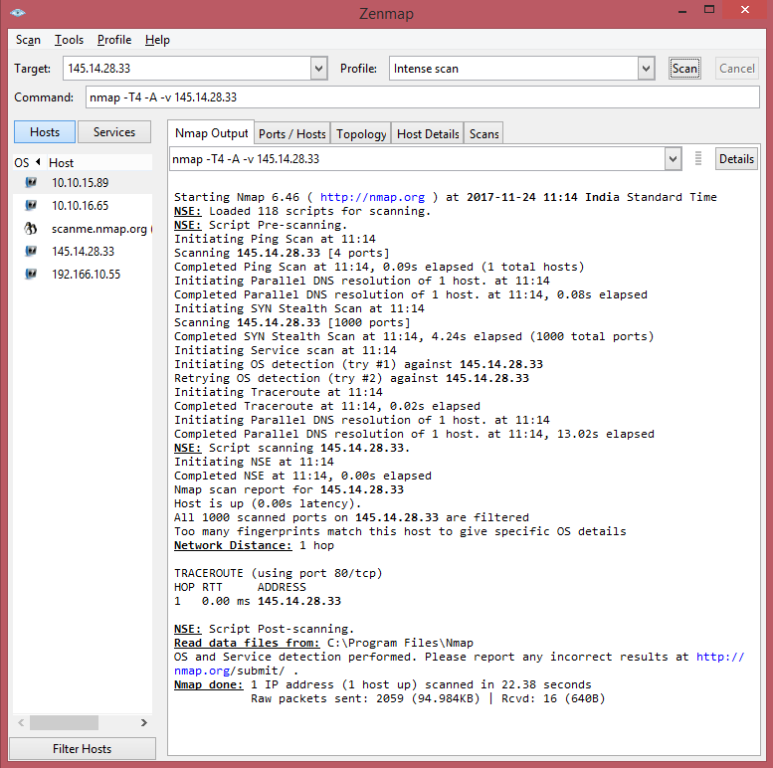

**The Ports / Hosts tab:**

The “Ports / Hosts” tab's display differs depending on whether a host or a service is currently selected. When a host is selected, it shows all the interesting ports on that host, along with version information when available.

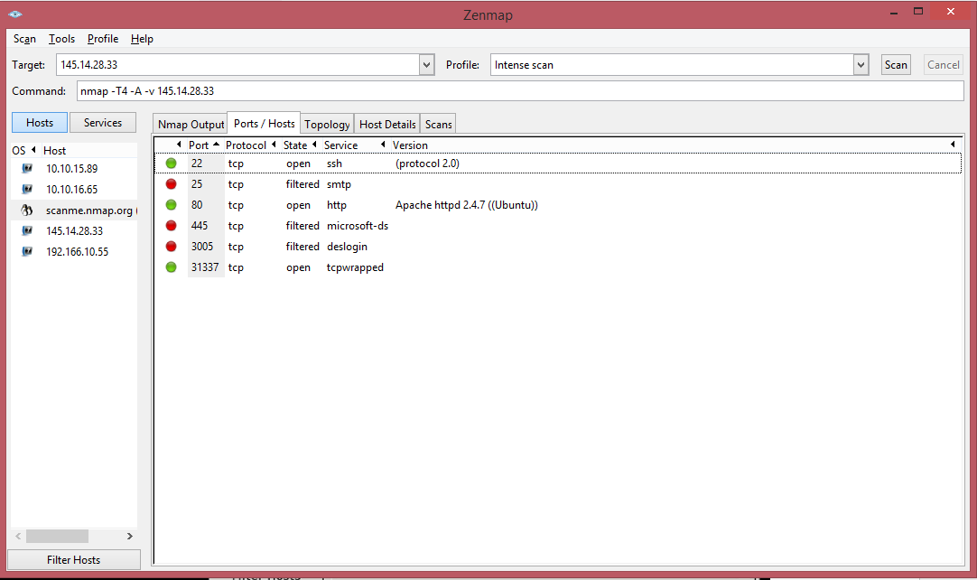

When a service is selected, the “Ports / Hosts” tab shows all the hosts which have that

port open or filtered.

**The Topology tab:**

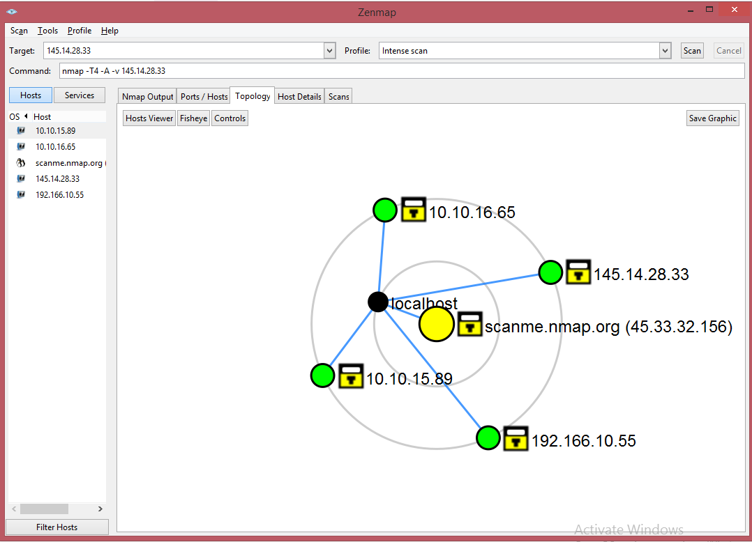

The “Topology” tab is an interactive view of the connections between hosts in a network. Hosts are arranged in concentric rings. Each ring represents an additional network hop from the center node. Clicking on a node brings it to the center. Because it shows a representation of the network paths between hosts, the “Topology” tab benefits from the use of the traceroute option.

**The Host Details tab:**

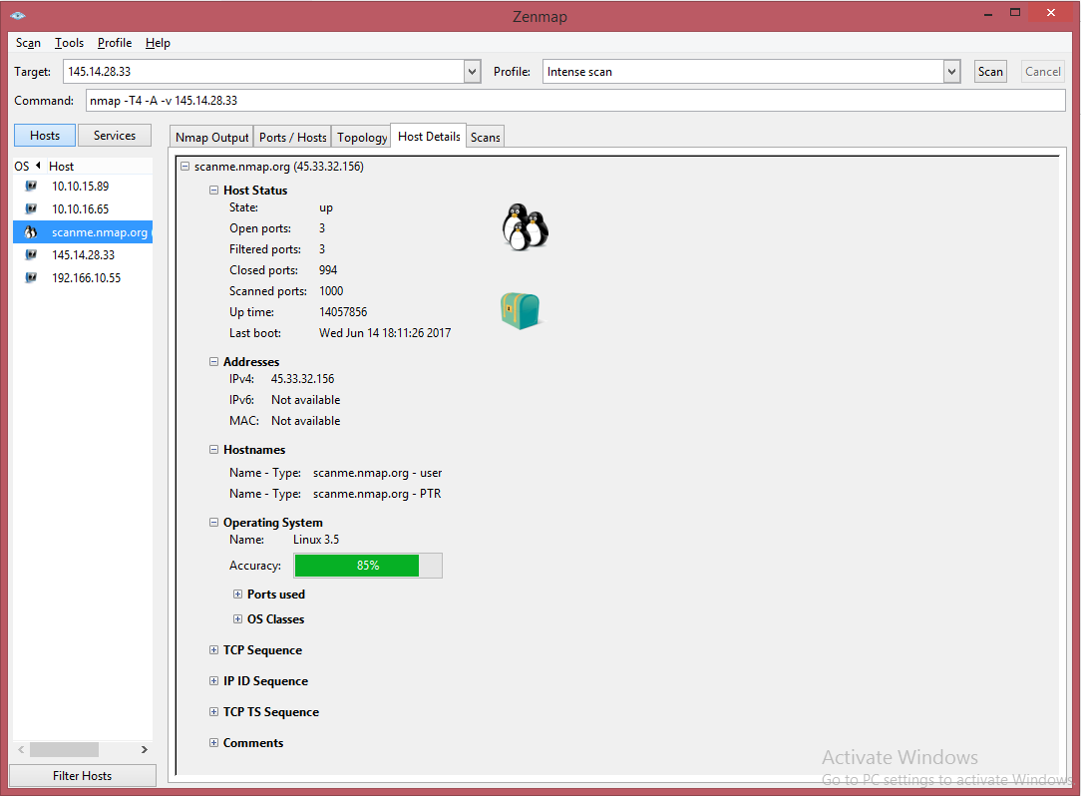

The “Host Details” tab breaks all the information about a single host into a hierarchical display. Shown are the host's names and addresses, its state (up or down), and the number and status of scanned ports. Each host has an icon that provides a very rough “vulnerability” estimate, which is based solely on the number of open ports. The icons and the numbers of open ports they correspond to are

they correspond to are

0–2 open ports,

3–4 open ports,

5–6 open ports,

7–8 open ports, and

9 or more open ports.

Interpreting Scan Results

Nmap's output is displayed during and after a scan. This output will be familiar to

Nmap users. Except for Zenmap'scolor highlighting, this doesn't offer any

visualization advantages over running Nmap in a terminal. However, other parts of

Zenmap's interface interpret and aggregate the terminal output in a way that makes

scan results easier to understand and use.

**Scan Results Tabs:**

Each scan window contains five tabs which each display different aspects of the scan

results. They are: “Nmap Output”, “Ports / Hosts”, “Topology”, “Host Details”,

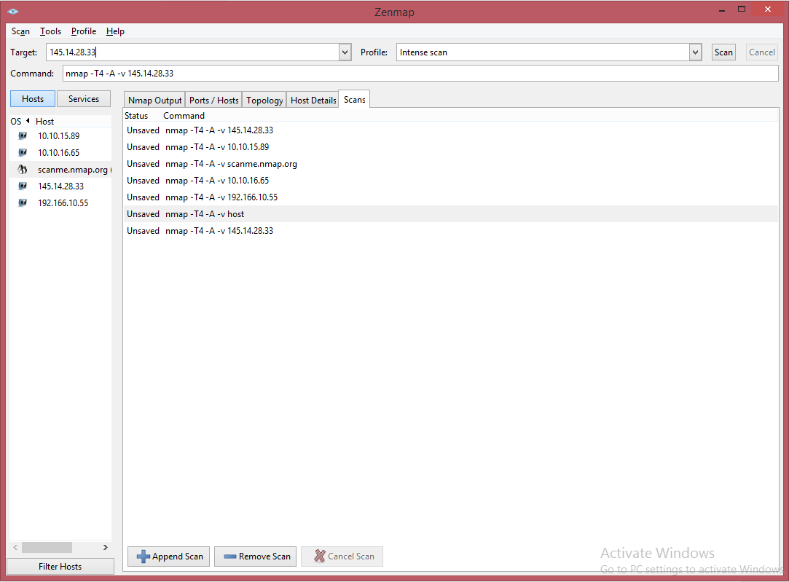

Sign:________

**Practical 9**

**Aim:** Socket Programming.

**Requirement:** jdk 1.8.

**Solution :**

**Client code:**

import java.net.*;

import java.io.*;

public class GreetingClient

{

public static void main(String [] args)

{

String serverName=args[0];

int port=Integer.parseInt(args[1]);

try

{

System.out.println("connecting to "+serverName+" on port "+port);

Socket client=new Socket(serverName, port);

System.out.println("just connected to "+ client.getRemoteSocketAddress());

OutputStream outToServer=client.getOutputStream();

DataOutputStream out=new DataOutputStream(outToServer);

out.writeUTF("Hello From"+client.getLocalSocketAddress());

InputStream inFromServer=client.getInputStream();

DataInputStream in=new DataInputStream( inFromServer);

System.out.println("server says "+ in.readUTF());

client.close();

}

catch(IOException e)

{

e.printStackTrace();

}

} }

**Server code:**

import java.net.*;

import java.io.*;

public class GreetingServer extends Thread

{

private ServerSocket serverSocket;

public GreetingServer(int port)throws IOException

{

serverSocket=new ServerSocket(port);

serverSocket.setSoTimeout(10000);

}

public void run()

{

while(true)

{

try

{

System.out.println("waiting for the client on porty" +serverSocket.getLocalPort()+ "...");

Socket server=serverSocket.accept();

System.out.println("just connected to"+server.getRemoteSocketAddress());

DataInputStream in =new DataInputStream(server.getInputStream());

System.out.println(in.readUTF());

DataOutputStream out=new DataOutputStream(server.getOutputStream());

out.writeUTF("Thanq for connecting to "+ server.getLocalSocketAddress()+ " \n GoodBye!" );

server.close();

}

catch(SocketTimeoutException s)

{

System.out.println("socket timeout!");

break;

}

catch(IOException e)

{

e.printStackTrace();

break;

}

}

}

public static void main(String [] args)

{

int port=Integer.parseInt(args[0]);

try

{

Thread t=new GreetingServer(port);

t.start();

}

catch(IOException e)

{

e.printStackTrace();

}

}

}

**Output:**

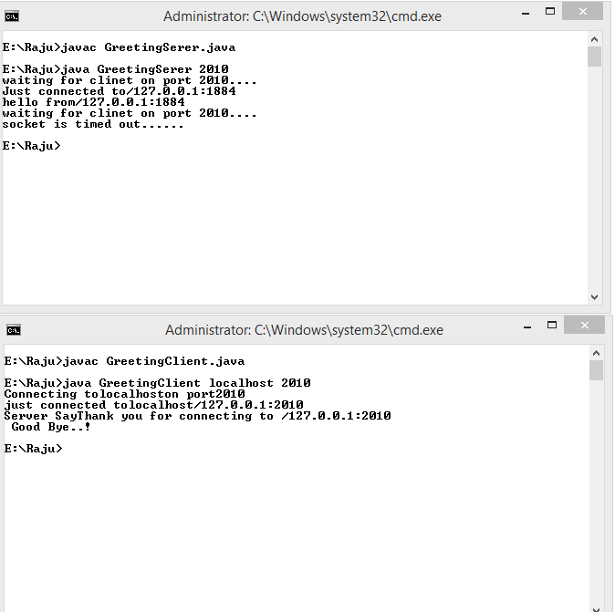

Sign:________

**Practical 10**

**Aim:** Exposure to client server concept of TCP/IP, Blowfish.

**Requirement:** NetBeans IDE 8.2.

**Solution:**

Create new project.

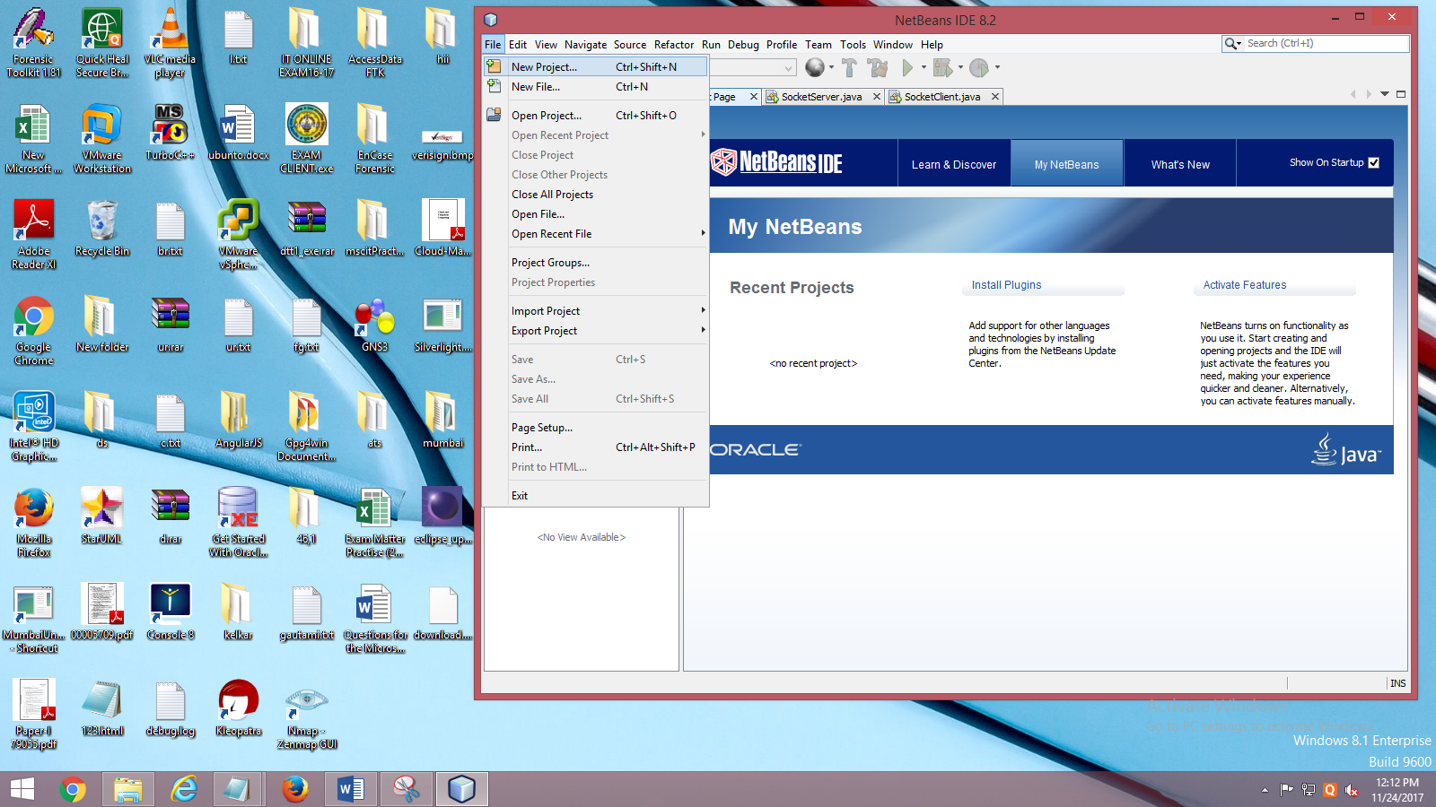

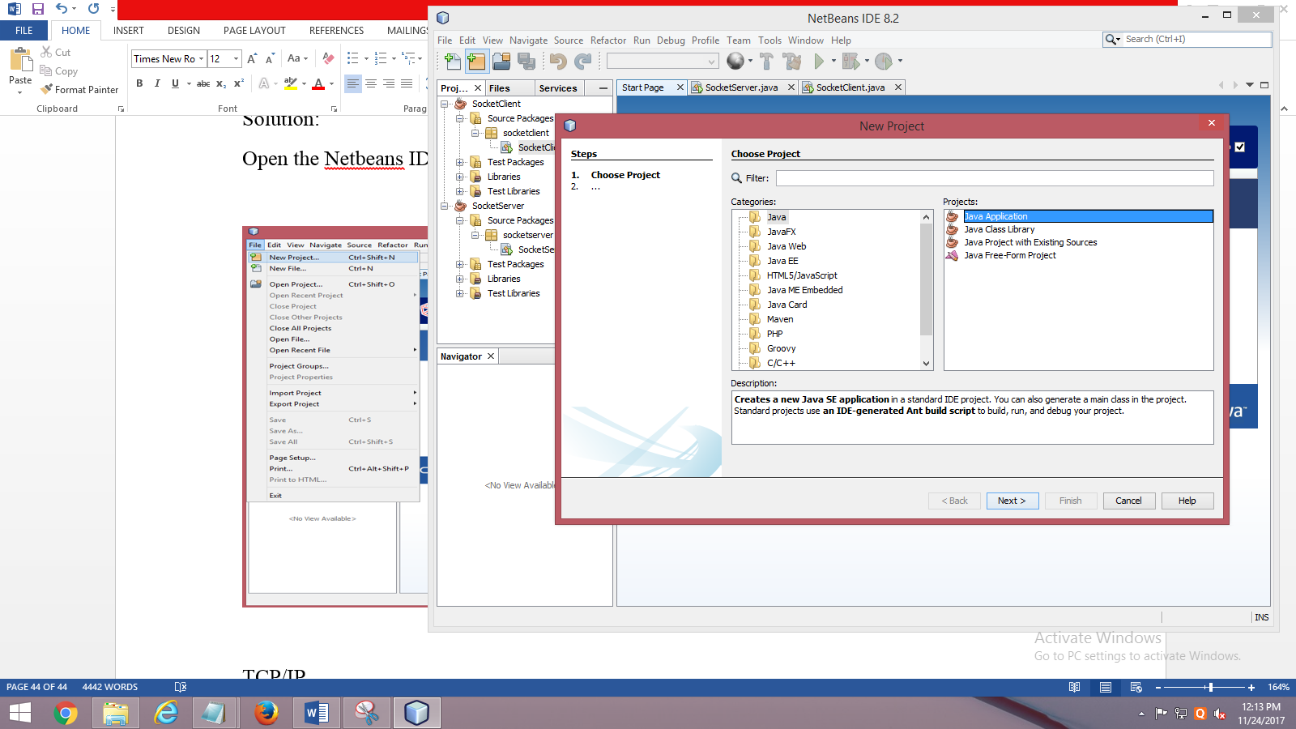

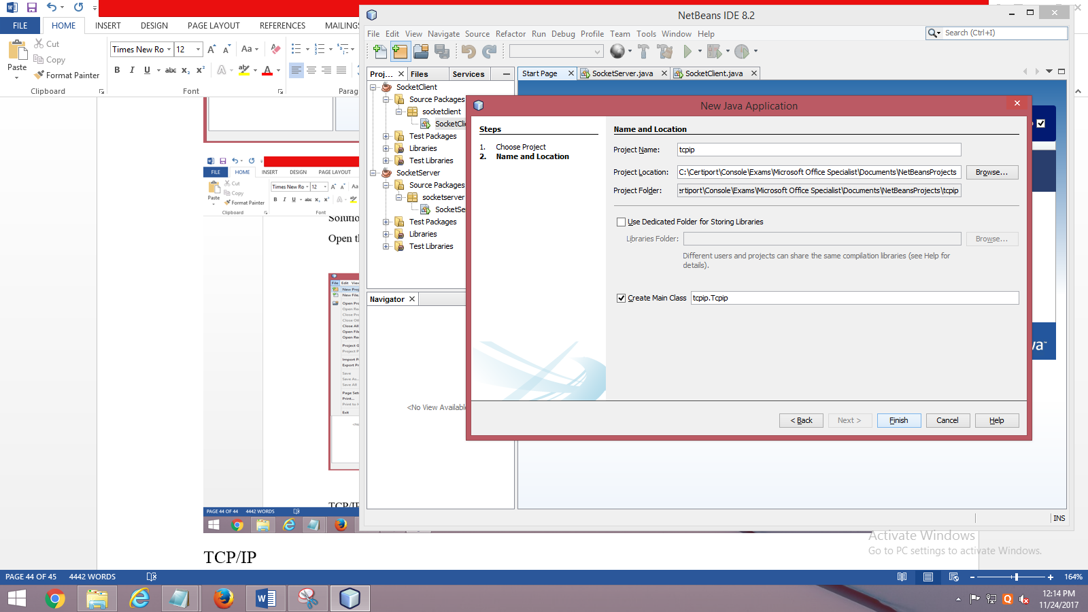

**Server program:**

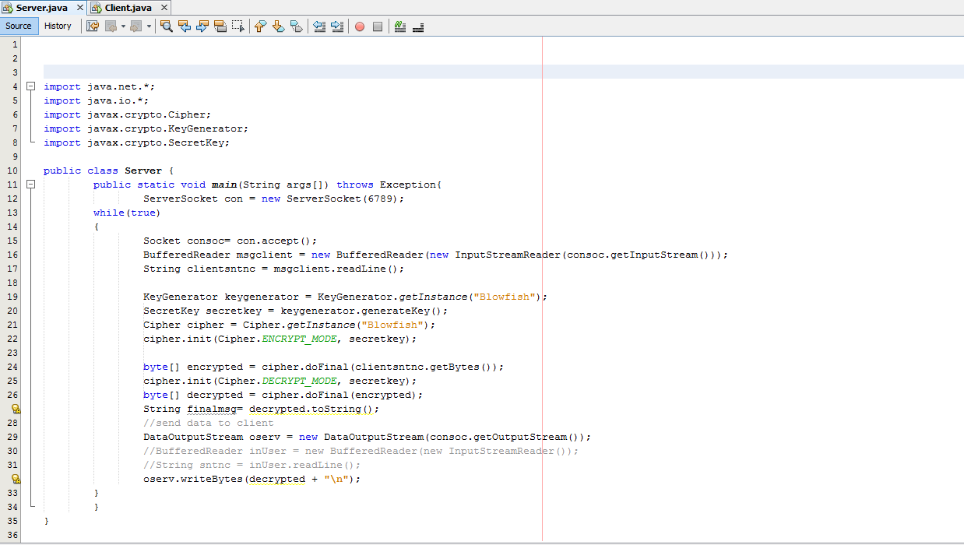

**Client Program:**

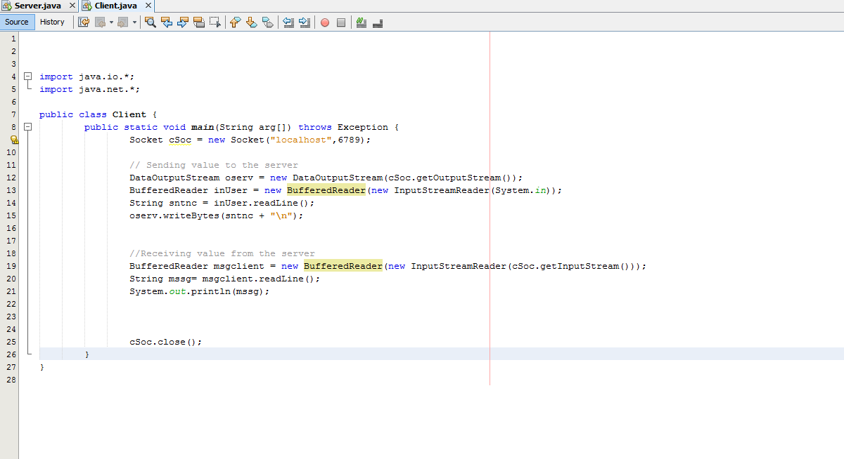

**Output:**

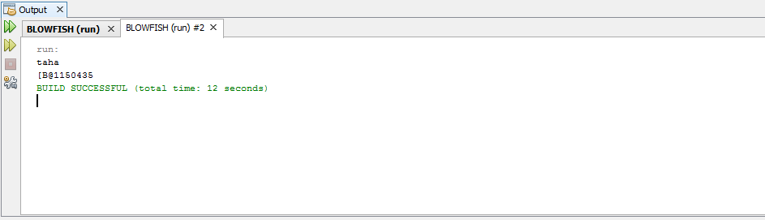

Sign:________